

The European
Union’s
ENPI Programme for
Ukraine

Support for the Implementation of the
EU-Ukraine Association Agreement
'Association4U - A4U' Project
EuropeAid/137074/DH/SER/UA
Contract N° 2015/370-128
Training Materials
on Evidence-Based Public Policy-Making
(four-day Training)
Kyiv, Ukraine

Developed by Senior Training Fellow Maryna Chulaievska according to Training materials shared during TOT by STE A. van Ballegoyen
This project is funded by the European
Union

A project implemented by a consortium
GFA Consulting Group GmbH

The document does not reflect opinions or standpoints of the EU. It reflects opinions sounded at the respective meeting as compiled by experts of the A4U Project.

Матеріали для читання до тренінгу:

“Формування публічної політики, заснованої на доказах”

Підготовлені старшим фахівцем

з тренінгових програм “A4U”

Мариною Чулаєвською

на базі англомовних матеріалів

експерта “A4U”

Ар’єна ван Балегоєна

Київ - 2018

LEARNING LINE 2 EVIDENCE-BASED PUBLIC POLICY MAKING
HANDBOOK

Learning line description
The evidence-based public policy making learning line is focused on developing the capacity of civil servants working with the strategic planning, policy formulation and policy implementation functions of government. The learning line is heavily focused on practical skills development to support civil servants in their policy-related work. The courses are fundamental/entry level courses that are suitable as an introduction to policy making knowledge and core policy making skills. The course covers most elements of the policy cycle with agenda setting except policy evaluation.
Learning line training methodology
The learning line is built specifically for practical skills acquisition. For this reason, all courses use demonstration cases to show the steps in applying a skill necessary to produce quality policy related outputs. Skill acquisition is supported in the course by having the participants practice the introduced skills on their own policy case. The courses can be used in a modular fashion making different combinations of courses to meet the needs of a specific audience. The use of the case study as the main vehicle for practicing skills links the courses as the participants can use their own case in all courses and even develop their case practicing skills needed for different parts of the policy cycle.
Overview of learning line courses
The learning line consists of four courses in one integrated cluster:
- Evidence-based public policy making (EBPPM (2.1)): The course is a fundamental level introduction to Evidence-based Public Policy Making that is aimed at developing the practical skills of civil servants to prepare public policy, based on thorough problem analysis and theory of change. There are three versions of this course 2.1.A, 2.1.B and 2.1.C.
- Regulatory Impact Assessment (RIA (2.2)): this course is focused providing participants with knowledge about RIA and its role in policy development. The course introduced some techniques commonly used in RIA, which are then applied to a policy case.
- Policy implementation planning (PIP (2.3)): this course is focused on planning both policy formulation and policy implementation, training participants in applied project cycle management skills to ensure that requests for policy development and policy implementation results can be delivered.
- Strategic planning (SP (2.4)): this course gives an overview of strategic planning at government-wide level as well as an organizational function. It covers concepts and skills related to strategic priority setting, scenario planning; decision-making and budgeting processes.
- ToT EBPPM capacity building (2.5) (Non-core): The learning line also includes a course on training trainers to train policy development courses. This course is not part of the core courses of the learning line but it supports this learning line and it facilitates sustainability of the learning line.

Course duration overview
Course | EBPPM | RIA | Policy Implementation | Strategic planning | Train the trainer EBPPM | Total
Training days | 4 days | 1 day | 4 days | 2 days | 2 days | 13 days (Core 11 days)

Course requirements
Number | Course | Requirement
1 | Evidence based Policy making (EBPPM) | No requirement
2 | Regulatory impact assessment (RIA) | No requirement, although it is recommended that the EBPPM course has been attended.
3 | Policy implementation planning | EBPPM is required for this course.
4 | Strategic planning | No requirement.

Competency framework
The learning line uses the OECD core competency framework to identify which competencies are strengthened by the various learning line courses. The OECD core competency framework is used as a stop-gap measure while waiting for the development of a specific competency framework for the civil service of Ukraine. Although Ukraine has a National Competency Framework in place, this framework does not specify what competencies would apply to the civil service. The OECD core competencies are quite general in nature and likely to be highly compatible with any competency framework that may emerge for the Ukrainian civil service.

OECD core competencies overview (OECD, competency framework 2014):
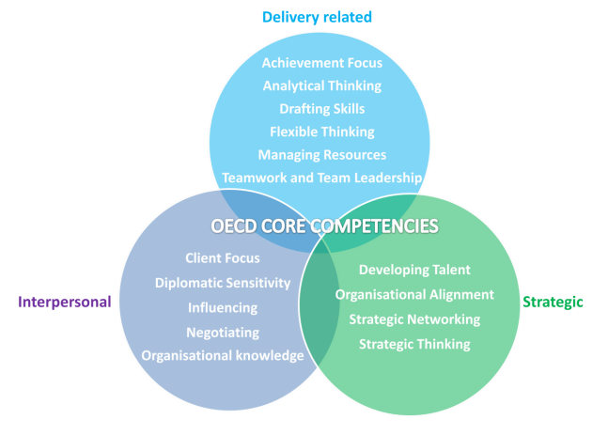
All learning line courses include a section identifying which of the above competencies are strengthened in the course and how heavily each course is focused on a particular competency. This is represented by the following ranking methods:
0 | No pips (0) | Competency is not strengthened in the course
1 | 1 pip (+) | Competency is marginally strengthened in the course
2 | 2 pips (++) | Competency is moderately strengthened in the course
3 | 3 pips (+++) | Competency is heavily strengthened in the course

The pips do not designate the complexity of the competency development content and such complexity varies from course to course, irrespective of focus pips.
Learning line competency focus
Nr. | Course  Competency | EBPPM | RIA | Policy implementation planning | Strategic planning
1 | Delivery related
1.1 | Achievement focus | +++ | ++
1.2 | Analytical thinking | +++ | +++
1.3 | Drafting skills | + (+++ course2.1.C) | 0
1.4 | Flexible thinking | +++ | +++
1.5 | Managing resources | 0
1.6 | Teamwork & team leadership | +++ | ++
2 | Strategic
2.1 | Developing talent | 0 | 0
2.2 | Operational alignment | 0 | 0
2.3 | Strategic networking | 0 | 0
2.4 | Strategic thinking | +++ | +++
3 | Interpersonal
3.1 | Client focus | +++ | +++
3.2 | Diplomatic sensitivity | 0 | 0
3.3 | Influencing | 0 | 0
3.4 | Negotiating | 0 | 0
3.5 | Organizational knowledge | 0 | 0

Linkage to other learning lines
Learning line 1: this learning line forms the background for the EBPPM learning line. AA/DCFTA, European integration and legal approximation are all topics of relevance to EBPPM as these topics are a key reason to prepare policy and conduct RIA. It is possible to combine courses from learning line 1 to EBPPM.
Learning line 3: this learning line focuses on the reform of the public administration which can have a significant impact on how and when the various EBPPM learning line skills are used. In particular, the PAR learning line provides the internal bureaucratic context of the EBPPM. It is possible to combine courses from this learning line with EBPPM courses, especially for higher echelon civil servants.
Learning line 4: this learning line is skills focused and as such compatible with the EBPPM when the learning line 4 courses are specifically applied to EBPPM topics, such as stakeholder consultation, negotiation between ministries in priority setting or policy development etc.

Course evaluation:
The course currently does not include a specific evaluation framework. However, this can be added in accordance with the needs of the client. The following course evaluation methods are recommended for the courses in this learning line:
- Skills acquisition and mastery: skills acquisition and mastery can be determined in a number of ways:
  - Intensive: provide an individual participant with a new policy case to be developed with the skills introduced in the various courses. The degree to which the outputs show good application of the introduced methods and techniques form the input for the evaluation.
  - Extensive: observation of the participant during group policy case work and asking questions during the application of the methods and techniques will form the basis for skills acquisition evaluation
  - Client centered: feedback from the client regarding the use of the skills, techniques and methods will provide information for skills mastery determination. This however requires that the participant is required to use the trained skills, techniques and methods in their work, which may not be the case.
  - Exam style: case analysis and policy option generation and explanation. The participants will have individual exams where they are presented with a case that they will have to prepare policy options for and for which they will have to pretend to give advice to their minister about the policy options. This will require application of most of the techniques and it can measure a degree of synthesis of the acquired skills. Variation of case focus will allow use of this evaluation method for different parts of the policy cycle and the corresponding course.
- Participant suitability for policy work and team work: this can be observed during the training days during the policy cases the participants will work on as these exercises are all group exercises. Formal and informal observation methods can be used where positive and negative behaviors are identified and tallied or where triangulated impressions from the trainer and additional observers are used over time to build up a robust suitability profile of the participant.

TRAINING COURSE OUTLINES

Course title | Evidence-based Public Policy Making (EBPPM) | Course code: 2.1.A
Key course information
Associated  Learning line | Learning line 2:  Evidence-based Public Policy Making
Course description | The course is a fundamental level introduction to Evidence-based Public Policy Making that is aimed at developing the practical skills of civil servants to prepare public policy, based on thorough problem analysis and theory of change.  The course is hands-on in nature as focuses on practical rather than theoretical policy development knowledge and skills that are introduced by means of an example case. Knowledge and skills are subsequently practiced during the course as participants work on their own case.  The course is updated regularly to reflect the context of the Ukrainian public administration, in particular the CABMIN rules of procedure. The course covers key tools, methods and techniques in line with the Better Regulation Toolbox
Target audience | The target audience are civil servants from the center of government, central line ministries, agencies, etc. involved in public policy making, including state experts and DGs. The course may also be applicable to civil servants from lower levels of government if they have public policy development duties.
Course duration | The duration of the course is 4 consecutive days.
Learning objectives | The participants will:  - know about the concept and theory of EBPPM;  - know about the typical analytical, stakeholder consultation and decision-making process regarding EBPPM;  - know how EBPPM relates to government priorities, the AA/DCFTA, legal approximation, CABMIN RoP and the electoral cycle in Ukraine;  - be able to use problem and objective tree analysis skills;  - be able to generate and elaborate policy options, including internal policy logic/theory of change;  - be able to prepare basic logical frameworks;  - (For course 2.1.C) be able to prepare basic policy papers.
Competencies | This course supports the following competencies:  - Analytical thinking (+++)  - Achievement focus (+++)  - Drafting skills (+) (+++ for 2.1.C)  - Flexible thinking (+++)  - Teamwork (+++)  - Client focus (++)  - Strategic thinking (+++)
Teaching methods | - Presentation  - Example case  - Group discussion, Q&A  - Group-based action learning (policy case)
Course evaluation | - Participation in case development (individual)  - Quality of case analysis (group)  - For 2.1.C: quality of policy paper (individual/group)
Course prerequisites | This course has no course prerequisites: it the fundamental, entry level course in this learning line.
Course variants | Truncated version without the logical framework (3-day course) | 2.1.B
 | Policy paper version, training participants to prepare a policy paper for their policy case (4-day course with one training day per week, with extensive homework) | 2.1.C

Course management information
Number of participants | Recommended number is 15 to 20 participants, no more than 5 participants per policy case group
Course materials | - Evidence-based public policy making presentation v5 | - Filename and location link
Further reading references | - Document name…. | - Filename and location link
Training equipment requirements | Flip-over sheets; differently colored, adhesive post-it notes; duct/masking tape to tape flip-over sheets to wall; sufficient floor and wall space for 4 to 5 groups of participants to work on policy case analysis; beamer.
Blended learning | Link ….
Course developer | Arjen van Ballegoyen PSC² | Email: arjen@psc2.nl ; governance_int@hotmail.com
Course trainers | Arjen van Ballegoyen | Email: arjen@psc2.nl ; governance_int@hotmail.com
Course trainers | Maryna Chulaievska
Course trainers | ….
Course trainers | ….
Course trainers | ….
Course trainers | …..

Training course details:
Course training arrangement
- This course is split between morning sessions in which theoretical information is provided about a particular topic, tools and techniques are explained by means of the demonstration case and afternoon sessions where participants work in groups on their own cases. The trainer supports the policy case groups by monitoring their progress and answering questions as well as providing advice. In this manner, the participants will gradually develop their case while practicing their techniques and tools. For course variant 2.1C. additional time at home or in the office is available to the participants to conduct this analytical work and the trainer can be available by email or office visits to offer support.
- For 2.1.C the course is provided once a week for four sessions. This is a tight timeframe for the course load and it will require significant work outside training hours by the groups to prepare their policy papers. It is useful for the trainer to be available to the groups outside of normal training days.
Course exercise description
The course is organized around a policy demonstration case
- The participants are asked to form groups of 4 to 5 people
- They are then asked to pick a central policy problem that the group will work on. The selected central problem should be approved by the trainer.
- The groups will write causes of the central problem on sicky notes and stick these on the flip over paper.
- The groups will organize and reorganize their problem causes until a solid problem tree appears. This happens with feedback from the trainer.
- The groups will have to determine and designate root/major and minor causes as well as what to exclude from the problem tree.
- The final problem tree is flipped into an objective tree.
- For each item in the objective tree several policy ideas need to be generated, to have no fewer than 20 policy ideas in total
- The groups will pick or combine the policy ideas that they wish to pick for development into policy options.
- The groups will present policy options to the trainer for feedback and review of internal logic.
- The groups would have to use that analysis to populate a logical framework.
- In case of course 2.1.C the groups will use the analysis to populate their template after which the trainer provides feedback on the policy papers.

Course evaluation
- This course is not normally evaluated in a formal manner. No exam is used to test participants on the knowledge part of the course materials.
- Instead, groups are evaluated on the basis of the application of the introduced skills, particularly in terms of the correct use of the techniques and the thoroughness in applying the techniques.
- The groups are also evaluated on the basis of their ability to develop alternative policy options that are fundamentally different from each other, especially using policy solutions that are not focused on legislative or awareness building instruments, but other instruments (such as use non-government actors or financial instruments) or a combination of policy instruments.
- Individual participants are evaluated on their participation in the group exercise, their understanding of the techniques and their ability to adjust to comments/feedback of the trainer in a manner that reflects increased understanding of the material.
- For course 2.1.C, the quality and thoroughness of the policy paper is a method for evaluation.

Competency development in this course
This course supports a number of competencies, primarily from the delivery related competency cluster.
- Analytical thinking (+++): the course is heavily focused on analytical thinking, introducing a number to techniques related to problem analysis, objective setting, option generation and the weighing of options. Furthermore, theory of change/chain of internal logic is introduced to ensure that policy options are directly related to the policy issue to be solved and that policy options have sound internal logic to make them effective in addressing the relevant policy issue.
- Achievement focus (+++): the course is focused at generating new and alternative policy options to solve existing policy issues. The discussion of internal logic of policy options further focuses participants on the need to develop solutions that are likely to deliver results for citizens.
- Drafting skills (+) (+++ for 2.1.C): drafting skills competency is strengthened by the attention during this course to present options for decision making with clear pros and cons to allow decision makers to make informed decisions. Course variant 2.1.C goes further in this competency as it practices both the drafting of SMART objectives as well as the writing of an actual policy paper in accordance with a template.
- Flexible thinking (+++): the participants are supported in developing flexible thinking by means of the extensive attention in the course to include different stakeholders to problem analysis and policy option generation to achieve a higher quality of results. The inclusion of different stakeholders enhances quality of policy options by including different points of view and more expert views into the process of developing policy options.
- Teamwork (+++): the course stresses the need to include stakeholders from different organizations and sectors and to work cooperatively to come to better solutions to policy issues. Furthermore, the policy case analysis by the participants is done by means of group work and this directly builds team work.
- Client focus (+++): the course focuses on solving problems of citizens rather than focusing on the problems of government. The focus is on uncovering why citizens and organizations do what they do and to prepare policy options that address such reasons for the purpose of achieving a change in behavior.
- Strategic thinking (+++): the course strongly supports strategic thinking in that the participants need to consider how their proposed policy options will impact on society and predict the impact of the policy options on the policy issue. The participants are encouraged to consider the adaptive behavior of stakeholders, beneficiaries and affected organization in response to policy options and to already consider how to strengthen the policy options to limit unwanted adaptive behavior.

Indicative Training Programme
Day 1
Time | Topic | Trainer/ facilitator
9:30 – 10:00 | Registration
10:00 – 10:15 | Introduction and welcome word
10:15 - 11:30 | Overview of programme – aim and outputs  EBPPM, policy agenda setting, problem analysis  Introduction of EBPPM and the problem tree analysis technique as a first step towards analysing a policy case. | Arjen van Ballegoyen, STE
11:30 - 11:45 | Networking, coffee
11:45 - 13:00 | EBPPM, policy agenda setting, policy paper template, problem analysis (cont.)  Introduction of EBPPM and the problem tree analysis technique as a first step towards analysing a policy case. | Arjen van Ballegoyen, STE
13:00 - 14:00 | Lunch break
14:00 - 15:30 | Participants use the problem tree technique on their own case  Practicing the problem tree technique by the participants on their own policy case. | Arjen van Ballegoyen, STE
15.30 – 15.45 | Networking, coffee
15:45 – 17:00 | Participants use the problem tree technique on their own case  Practicing the problem tree technique by the participants on their own policy case. | Arjen van Ballegoyen, STE

Day 2

Time | Topic | Trainer/ facilitator
9:30 – 10:00 | Registration
10:00 - 11:30 | EBPPM Policy – Objective tree analysis & policy option generation  Introduction by the trainer of the objective tree technique and the technique for generating policy ideas and selecting policy ideas to become policy option | Arjen van Ballegoyen, STE
11:30 - 11:45 | Networking, coffee
11:45 - 13:00 | EBPPM Policy – Objective tree analysis & policy option generation (cont.)  Introduction by the trainer of the objective tree technique and the technique for generating policy ideas and selecting policy ideas to become policy option | Arjen van Ballegoyen, STE
13:00 - 14:00 | Lunch break
14:00 - 15:30 | Participants use the objective tree technique on their own case  Practicing the objective tree approach | Arjen van Ballegoyen, STE
15.30 – 15.45 | Networking, coffee
15:45 – 17:00 | Participants use the objective tree technique on their own case (cont.)  Practicing the objective tree approach | Arjen van Ballegoyen, STE

Day 3

Time | Topic | Trainer/ facilitator
9:30 – 10:00 | Registration
10:00 - 11:30 | Policy option elaboration and policy option logic  Introduction of the need to develop policy options and the manners in which to do so. Introduction of the chain of logical steps technique to determine and improve the internal logic of policy options. Introducing and applying the logical framework methodology to the example policy case | Arjen van Ballegoyen, STE
11:30 - 11:45 | Networking, coffee
11:45 - 13:00 | Policy option elaboration and policy option logic (cont.)  Introduction of the need to develop policy options and the manners in which to do so. Introduction of the chain of logical steps technique to determine and improve the internal logic of policy options. Introducing and applying the logical framework methodology to the example policy case | Arjen van Ballegoyen, STE
13:00 - 14:00 | Lunch break
14:00 - 15:30 | Participants use the chain of logical steps technique on their own case  Practicing the policy option elaboration and policy option logic techniques. Practicing the logical framework technique | Arjen van Ballegoyen, STE
15.30 – 15.45 | Networking, coffee
15:45 – 17:00 | Participants use the chain of logical steps technique on their own case (cont.)  Practicing the policy option elaboration and policy option logic techniques. Practicing the logical framework technique | Arjen van Ballegoyen, STE

Day 4
Time | Topic | Trainer/ facilitator
9:30 – 10:00 | Registration
10:00 - 11:30 | Performance framework & policy paper population  Preparing a performance framework for policy papers. | Arjen van Ballegoyen, STE
11:30 - 11:45 | Networking, coffee
11:45 - 13:00 | Performance framework & policy paper population (cont.)  Preparing a performance framework for policy papers. | Arjen van Ballegoyen, STE
13:00 - 14:00 | Lunch break
14:00 - 15:30 | Presentation and discussion of policy cases Presentations by the group and discussion and feedback by the group and the trainer. | Arjen van Ballegoyen, STE
15.30 – 15.45 | Networking, coffee
15:45 – 17:00 | Presentation and discussion of policy cases Presentations by the group and discussion and feedback by the group and the trainer. | Arjen van Ballegoyen, STE

актуальність тренінгового курсу

Міністерства мають розробити політики на запити Кабінету Міністрів України і для реалізації Угоди про Асоціацію та Поглибленої і всеосяжної зони вільної торгівлі (ПВЗВТ).
Основні засади формування та реалізації державної політики визначаються відповідно до Регламенту Кабінету Міністрів України (Регламент).
Зазначимо, що в Україні використовуються різні терміни: державна політика і публічна політика. В даному курсі використовується термінологія відповідно до Глосарію, розробленого спільно фахівцями проекту «Асоціація для тебе» та НАДУ 2018 року.

Параграф 3-1 Регламенту визначає, по суті, послідовні кроки формування та реалізації державної політики та фактори, які обов’язково мають враховуватись в цьому процесі.
Так, забезпечення формування та реалізації державної політики здійснюється міністерствами шляхом:
- вивчення стану справ у відповідних сферах;
- визначення суспільно важливих проблем, що потребують розв’язання, та їх пріоритезації;
- пошуку оптимальних шляхів розв’язання проблем;
- розроблення концепцій реалізації державної політики у відповідних сферах;
- планування ресурсів та заходів, необхідних для реалізації державної політики;
- розроблення проектів законодавчих актів, інших актів законодавства, здійснення контролю за виконанням прийнятих актів;
- проведення моніторингу та оцінювання результатів реалізації державної політики та розроблення на основі такого оцінювання пропозицій щодо її продовження, коригування чи припинення.
Під час формування та реалізації державної політики необхідно враховувати:
- стратегічні цілі, визначені Програмою діяльності КМУ, іншими стратегічними та програмними документами;
- суспільно важливі проблеми, що потребують розв’язання;
- а також міжнародні зобов’язання України, зокрема передбачені Угодою про асоціацію між Україною та ЄС.

Методологія тренінгу

Це практично-орієнтований курс, під час якого пропонуємо вам обрати тему, що безпосередньо стосується роботи державного органу, в якому ви працюєте, є нагальною і пов’язана з впровадженням Угоди про асоціацію. За результатами тернінгу ви зможете підготувати пропозиції з розробки політики.
Тренер буде використовувати один кейс як приклад для роз’яснення методів. Після роз‘яснення учасники використовиватимуть представлені методи для своїх кейсів/тем. Тренер курсу буде надавати коментарі відповідно до виконаних завдань. Звертайтесь із будь-якими запитання до тренера та будьте готові до діалогу.
Після етапу підготовки (тренінгу) учасники зможуть використовувати матеріали курсу для допомоги державним службовцям з різних міністерств.

вибори та цикли стратегічного планування

ELECTION AND STRATEGIC PLANNING CYCLES

ЩО ТАКЕ ПОЛІТИКА?

Політика (policy) – це план реалізації щодо втілення в життя певної реформи/стратегії, а також система моніторингу для оцінювання, чи все виконується вчасно для досягнення цілей. Політики, що розроблені та підтримані інституціями державного управління, є найкращими інструментами для досягнення результатів сучасними урядами.
Політики, що розроблені та підтримані інституціями державного управління, є найкращими інструментами для досягнення результатів сучасними урядами.
Політики включають декілька складових:
- Цілі, в яких зазначається, які саме потреби необхідно задовільнити;
- Стратегія щодо досягнення цілей;
- Затвердження уповноваженими особами обраної стратегії як офіційного напрямку, що буде застосований урядом для досягнення цілей;
- План реалізації щодо втілення в життя стратегії (що саме ми робимо);
- Система моніторингу для оцінювання, чи все виконується вчасно для досягнення цілей.
- Додатково, політики потребують бюджету для реалізації та для забезпечення життєспроможності політики.

Обгрунтована політика скеровує Уряд на досягнення результатів, адже:
- Кабмін має показати результати громадянам, щоб мати виграшну позицію на наступних виборах, сформувати уряд та залишитися при владі;
- Кабмін має продемонструвати результати міжнародним структурам (Європейському Союзу, МВФ, ЄБРР тощо) та іноземним державам (США, Німеччина, Франція та ін), для того, щоб отримати доступ до ресурсів (фінансових, матеріальних тощо).

Під час формування публічної політики необхідно враховувати виборчі цикли.
Виборчий процес та п’ятирічний термін перебування при владі визначає, скільки є часу для досягнення результатів. Ниже наведено логічну матрицю формування публічної політики в контексті виборчого циклу.
логічна матриця

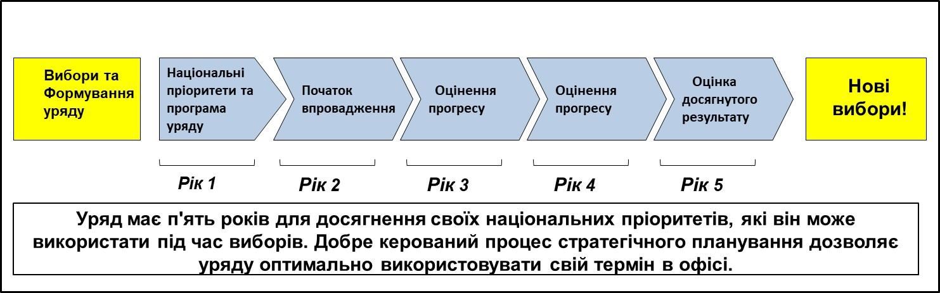

Наступною умовою успішної політики є те, що саме Міністертва мають втілити в життя очікувані результати.
Кабмін звертається до окремих міністерств та міністрів для підготовки і реалізації політик для досягнення цілей уряду.
Міністерства підзвітні Кабміну за досягнення результатів в сферах їхньої діяльності. Міністерства також підзвітні Верховній Раді за реалізацію політичних рішень в їх сферах впливу.
Це саме ті СТЕЙКХОЛДЕРИ, з якими треба працювати на етапі розробки політики. Рівень взаємодії, діалогу та взаємопорозуміння між цими стейкхолдерами визначає ймовірність її затвердження і ефективність реалізації.

Завданням персоналу департаментів стратегічного планування є розробка варіантів політики, підготовка планів реалізації та моніторингу реалізації політик іншими департаментами міністерства або іншими організаціями для забезпечення досягнення цілей політики.

Державні службовці мають зобов’язання надавати послуги найвищої якості своїм міністрам незалежно від того, яку політичну партію представляє міністр і чи має вона/він професійні заслуги.

Нижче наведена схема взаємозв’язку між стратегічними пріоритетами та формуванням політики

УА/ПВЗВТ
Політичні партійні програми
Бюрократичні пріоритети
Пріоритети політики міністерства
Розробка політики міністерства

Коаліційна угода
Реалізація політики Міністерства

Оцінка
політики Міністерства
Стратегічні пріоритети уряду

як адаптація законодавства пов’язана з розробкою політики

Угода про асоціацію передбачає наближення законодавства України до права ЄС, що втілюється шляхом правової адаптації або апроксимації.
Багато пріоритетних дій уряду України спрямовані на адаптацію законодавства ЄС.
Через значний обсяг законодавства, яке треба адаптувати, може скластись враження, що адаптація законодавства це лише проблема нормотворення, яка потребує внесення змін до існуючих чи розробки нових законів України.
Проте, це насамперед, необхідно вирішити питання наявності політики, а вже потім приступати до нормотворення.
Відповідно до параграфа 3-1 нормотворча діяльність є лише одним із кроків, який спрямований на створення умов для реалізації політики. Цей підхід є принципово важливим, оскільки часто замість формування політики здійснюють нормотворчу діяльність, що не призводить до бажаного результату, оскільки робота є безсистемною, необґрунтованою і неспрямованою на досягнення певного результату.

Правовий доробок ЄС передбачає досягнення кінцевих результатів у будь-якій сфері політики: рух товарів, надання послуг, захист споживачів, виробництво тощо. Тобто, будь-який документ має бути спрямований на досягнення певного результату.
Ці результати можуть передбачати не лише оновлення правової бази, а й:
- оновлення планів дій урядових структур;
- переформатування уряду;
- запровадження нових та/або оновлення процесів та процедур;
- стабільне фінансування для підтримки нової ситуації; тощо.
Тому адаптація законодавства може спровокувати системну реорганізацію в конкретній сфері. В такому випадку Інституційна система, процедури прийняття та вибору варіантів політики стають базою, на якій відбувається оновлення правової системи держави.

В чому полягає формування публічної політики, заснованої на доказах (ФППД)?

ФППД має на меті забезпечити відповідний зв'язок між формуванням політики та раціональним мисленням, науковим наповненням, емпіричними дослідженнями та доказами.
ФППД розглядається як протиставлення ідеології та упередженої політики.
ФППД спрямована на підвищення ефективності політики для досягнення бажаного результату та впливу.

ФППД та емпіричний цикл

Базою ФППД є часткове застосування наукових та емпіричних підходів до циклу політики.
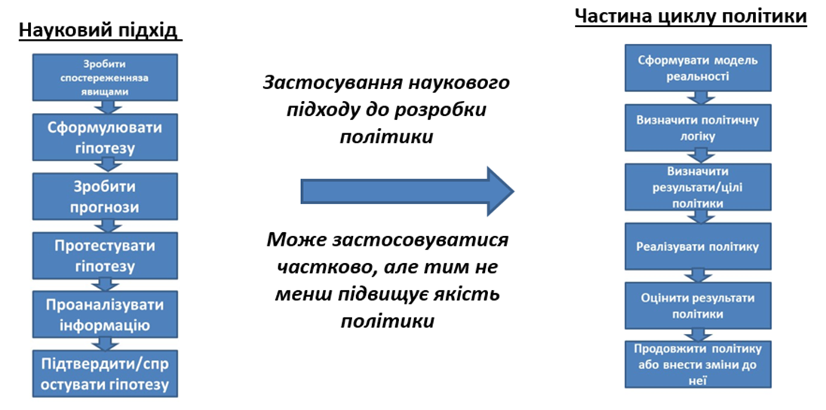

Наведемо декілька прикладів застосування доказових підходів до формування політики:
- Експертні консультації (моделювання у реальному часі, логіка політики);
- Зацікавлені урядові установи (моделювання у реальному часі, логіка політики);
- Консультації з населенням/бізнесом (моделювання у реальному часі, логіка політики);
- Логічна модель/теорія змін (моделювання у реальному часі, логіка політики, мета та цілі);
- Прогноз кількісного впливу (моделювання у реальному часі, логіка політики, мета та цілі);
- Прогноз якісного впливу (моделювання у реальному часі, логіка політики, мета та цілі);
- Порівняльні дослідження політики (все);
- Пошукові/Пілотні дослідження (імплементація політики, оцінка результатів);
- Вивчення оцінки ефективності політики (оцінка результатів, логіка політики, мета та цілі);
- Емпіричні дослідження (все).

“аналіз проблем”

“PROBLEM ANALYSIS” SECTION

ВИЗНАЧЕННЯ ТА АНАЛІЗ РЕАЛЬНОЇ ПРОБЛЕМИ

Насамперед, необхідно визначити реальну проблему та розглянути її більш детально

Впродовж цієї фази головна увага має бути зосереджена на аналізі проблем та розумінні різних підпричин проблем.

Ставтесь до пробеми критично. Іноді проблема, як і її причини та підпричини, може здаватися очевидною, проте при більш ближчому аналізі, ситуація може виглядати складнішою.


Наприклад:

Проблема:
- прірва?
- відсутність мосту? чи
- неможливість

перейти на інший бік?

Якщо Кабмін, міністр чи ЗМІ вже визначили «проблему» та її «причини», то додатковий аналіз зможе показати, чи визначення було правильним.

Під час аналізу проблеми чітко розмежовуйте її причини та симптоми, адже симптоми це прояви проблеми, усунення яких не приведе до її вирішення, але забере багато часу та інших ресурсів.

Подібно до лікарів, ми маємо правильно визначити причини проблеми для того, щоб знайти правильне рішення для подолання проблеми. Якщо діагностика проведена неправильно, то ми не зможемо вирішити головну проблему, згаємо час, людські ресурси та гроші.

Формування публічної політики, заснованої на доказах, ґрунтується на наукових дослідженнях, експертних оцінках, аналізі кейсів, порівняльних дослідженнях політики та висновках, для того, щоб дійти кращого розуміння проблеми, знайти ефективні шляхи вирішення та необхідні умови втілення.

Якість доказової бази та її інтерпретація — запорука успішного вироблення політики. Політичні консультанти повинні добре поміркувати над потенційними джерелами інформації, як-от офіційна статистика, наявні внутрішні дослідження, дослідження науковців, об’єднань, аналітичних центрів тощо, результати оцінювання, опитування, панельні дослідження та інші первинні дослідження (якщо це доцільно та можливо), поради експертів і свідчення як зацікавлених осіб, так і осіб, на яких вплине проект. ІКТ можуть відігравати важливу роль у виробленні політики на основі доказової бази, зокрема, у формі використання великих даних, моделювання та створення прототипів.
Як варіант, можна делегувати збирання та оцінювання доказів спеціалізованому державному органу, котрий займається дослідженнями і аналізом.

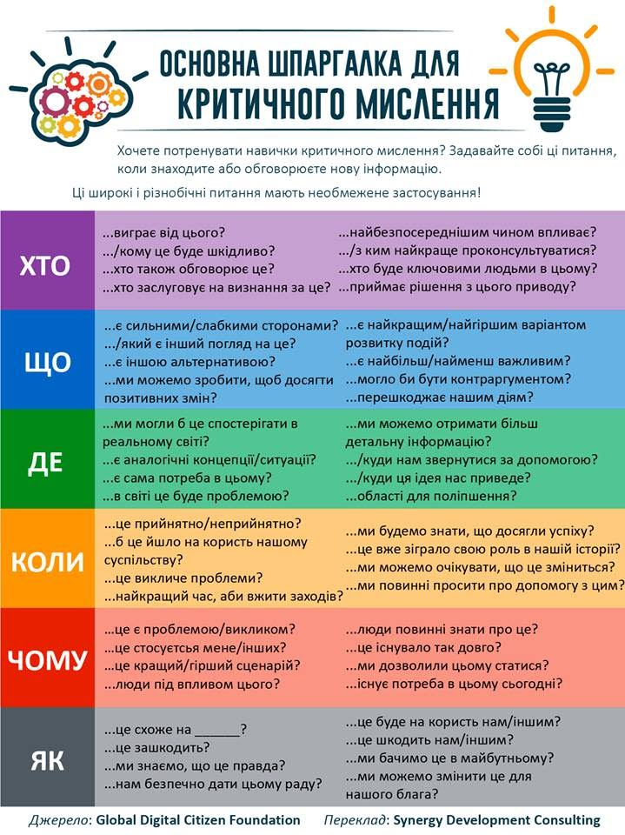

Використання методу
«Дерево проблем»

Міністерства мають бути заохочені використовувати метод «Дерева проблем». Метод «Дерево проблем» – простий, проте ефективний метод для поділу проблеми на менші частини та для визначення підпричин проблем.

Метод «Дерево проблем» легко використовувати в рамках групової роботи. Міністерства можуть залучати експертів з різних управлінь, агенцій, різних стейкхолдерів для участі у виконанні завдання з метою отримати різні точки зору щодо проблеми.

Метод «Дерево проблем» також дозволяє перейти від аналізу проблем до пошуку рішень.

Використання цієї методики підвищує якість аналізу проблем

Перевагою використання цієї методики є можливості розробників політики до розгляду різних аспектів проблеми, розширення глибини та ширини можливих проблем.

Цей більш широкий та глибинний аналіз проблем, в кінцевому підсумку, приведе до розробки кращих варіантів рішень політики.

Під час застосування методу «Дерево проблем» можна використовувати один із способів, які ддопоможуть систематизувати ваші думки та побачити логічну схему проблеми:
- Стікери та фліпчарт.
- Таблицю Exel.
- Програмне забезпеченя:

Порівняльний аналіз проблем та його наслідки

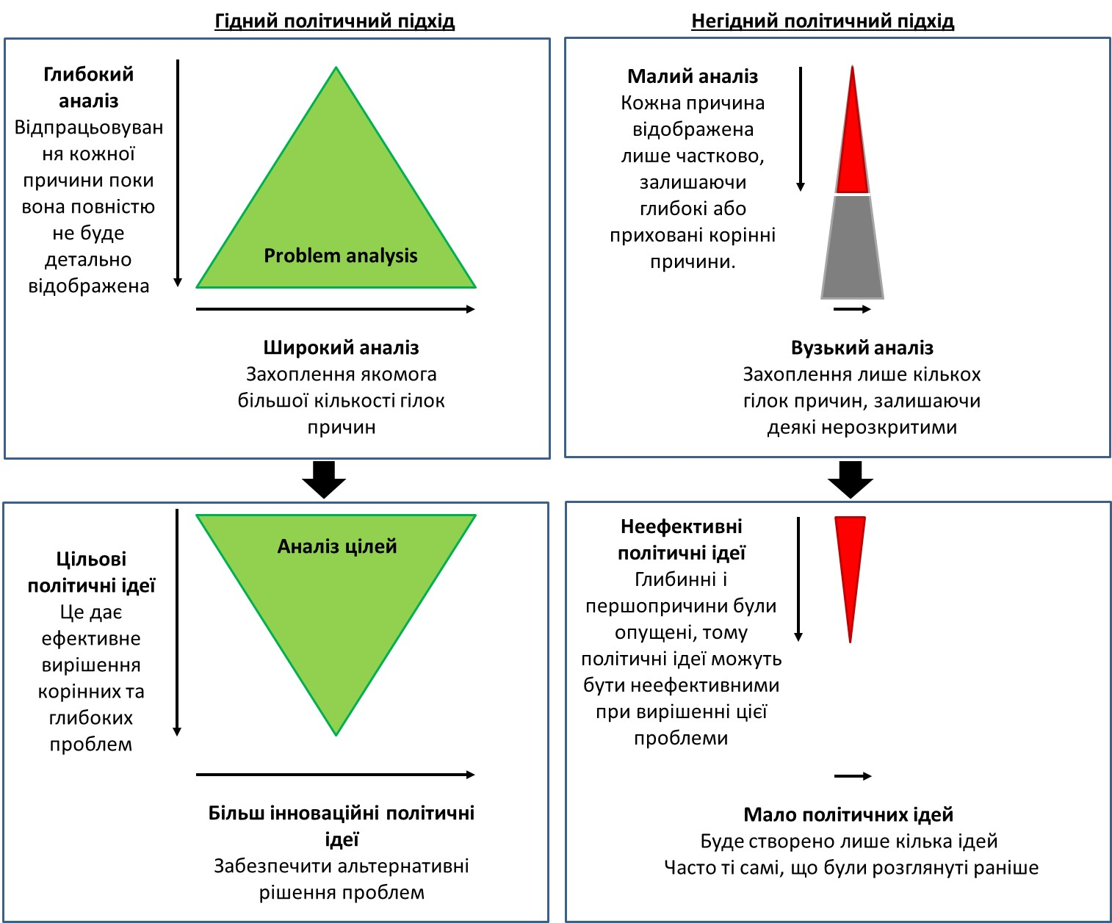

Наслідки неякісного аналізу для розробки варіантів політики

Ніколи не розглядається
Ніколи не розглядається
Не розкрито
Ідеї для політики
не створюються
Ідеї для політики
не створюються
Ідеї для політики
не враховували
ці змінні
Головна проблема
Велика вірогідність виникнення
невідповідної, неефективної та старої ідеї

Аналіз дерева
проблем
Формулювання
проблеми
Аналіз дерева
цілей
Вибір
Ідеї для політики

ПРИНЦИПИ ВИКОРИСТАННЯ МЕТОДУ «ДЕРЕВО ПРОБЛЕМ»
- Визначте проблему для аналізу і запишіть її одним реченням (“Низький рівень відвідування тренінгів державними службовцями”)
- Використовуйте мозковий штурм для вироблення переліку проблем та їх причин, які призводять до виникнення головної проблеми;
- Запишіть проблеми та їх причини на стікерах та розмістіть їх на дошці (або зробіть це за допомогою комп’ютерної програми);
- Згрупуйте проблеми та їх підпричини в групи (кластери), що пов’язані між собою;
- Перевіре кластери на наяність повторювань;
- Визначте та згрупуйте невеликі пов’язані між собою елементи;
- Проаналізуйте кластери на предмет, що є коренем проблеми, підпричинами.
- Викресліть зайві елементи.

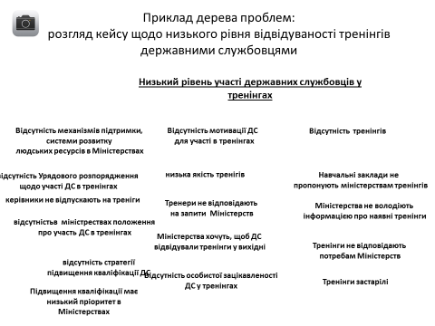

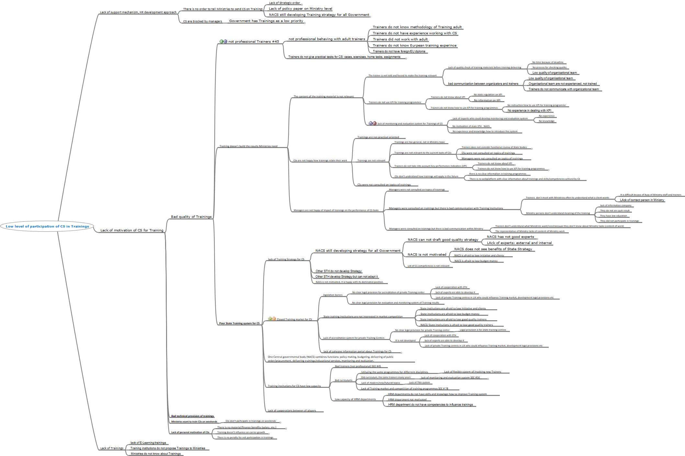Приклад дерева проблем: конкретизація і розбивка на кластери

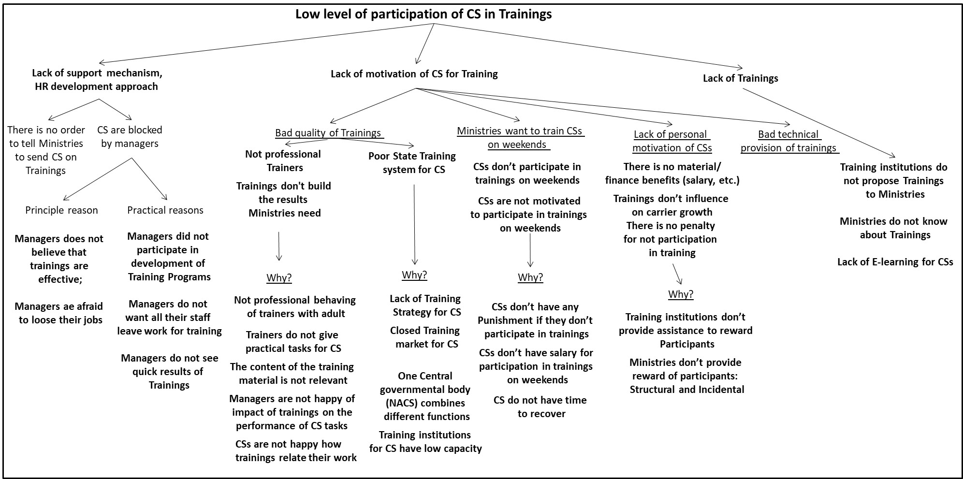

Глибинний аналіз проблем

Після організації та затвердження всіх елементів, можна перейти до глибинного аналізу.

В рамках аналізу ми спробуємо визначити:
- Що є коренями та головними підпричинами (факторами) проблеми?
- Що є незначними супроводжуючими факторами для виникнення проблеми;
- Які зв‘язки є між підпричинами?
- Які є інші причини, які безпосередньо не стосуються головної проблеми?
- Які проблеми чи підпричини не стосуються проблеми, є не на часі, є дрібними, нечасто виникають або існують тільки в теорії?

Як ми визначаємо основні підпричини (корені проблеми) і незначні підпричини для проблеми?
- Кореневі проблеми – це ті проблеми, що або повністю або у значній мірі спричиняють виникнення проблеми. Якщо ви виключите корені проблеми з розгляду, проблема або припинить існувати або значно зменшиться її актуальність, серйозність.
- Супутні проблеми (причини, що сприяють проблемі) - це ті причини, що можуть погіршити проблему, посиливши її корені, або в інший спосіб. Проте причини, що сприяють проблемі – це відносно незначне джерело проблеми, і при усуненні таких причин проблема не зменшиться.

Якщо взаємодія (співвідношення) між двома підпричинами, що призводить до виникнення проблеми, і сама проблема зникнуть при усуненні однієї з підпричин, тоді взаємодія (співвідношення) між підпричинами і є коренем проблеми.

Дерево проблем: аналіз проблем

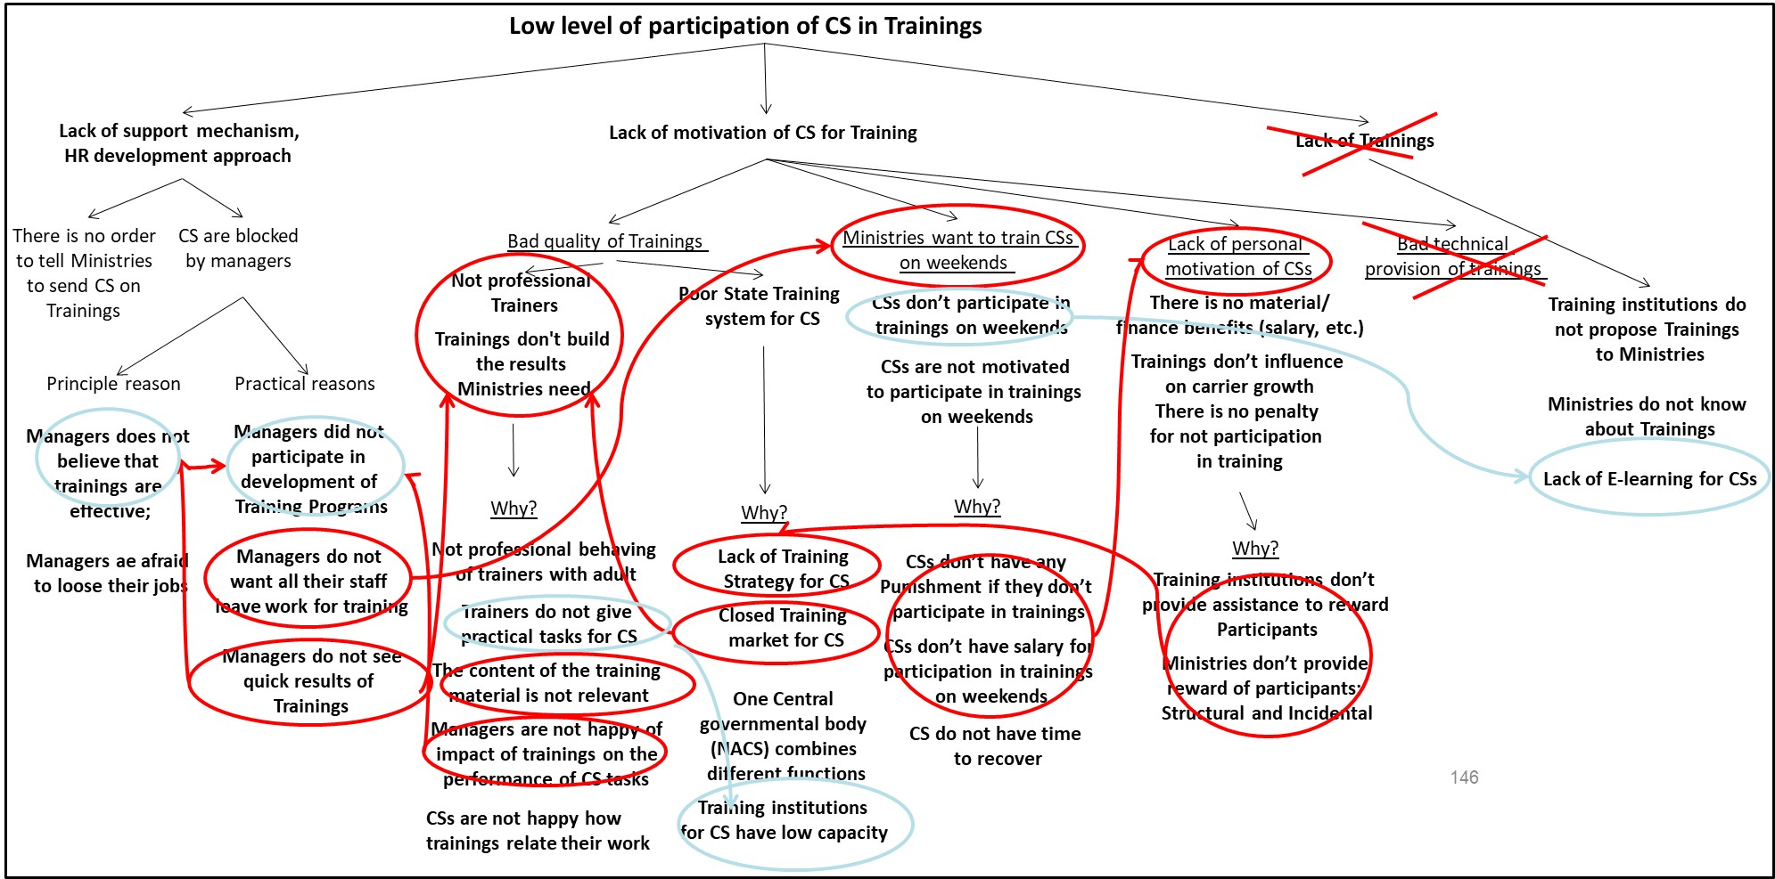

слайд

Макробачення аналізу проблем

Висновки, що були зроблені під час аналізу проблем:
- Підпричина, пов’язана з відсутністю тренінгів на ринку, не є основним фактором. Хоча існує проблема з якістю тренінгів, інформуванням міністерств та поширенням інформації про тренінги всередині міністерств про наявні тренінги, що звичайно, зменшує рівень участі ДС, однак все-таки певна кількість тренінгів на ринку існує і, якщо не про всі, то принаймні про деякі тренінги ДС поінформовані. Через те, ця частина дерева проблем може бути усунутою як така, що не має великого значення.
- Частина дерева проблем, що описує відсутність мотивації ДС до участі у тренінгу, включає погану якість тренінгів, бажання міністерств підвищувати кваліфікацію ДС у їх вільний/не робочий час, відсутністю особистого бажання в ДС, погане технічне забезпечення тренінгів. Остання підпричина може бути виключена з дерева проблем, оскільки, як показує досвід, відсутність кондиціонера в приміщенні, тісні кімнати, напівпідвальні приміщення не впливають визначальним чином на відвідуваність тренінгів, якщо забезпечуються інші складові, як от: наявність наказу керівництва, високий рівень тренера чи змісту тренінгу. Інші підпричини такі як: бажання міністерств підвищувати кваліфікацію ДС у їх вільний/не робочий час, відсутністю особистого бажання в ДС також можуть бути усунуті за умови подолання інших підпричин: відсутність механізму підтримки з боку відділів кадрів, відсутність наказу по міністрерствах та ін.
- Відсутність механізму підтримки ДС з боку відділів кадрів та підходу спрямованого на розвиток кадрів вважається важливою проблемою і складається з двох «гілок», що демонструють важливі підпричини проблеми. Одна із них стосується відсутності наказу по міністерствах щодо участі ДС у тренінгах. Друга «гілка» стосується особистого небажання керівництва відпускати підлеглих на тренінги. Обидві «гілки» пов’язані між собою. Друга «гілка» має практичні та принципові причини, які при цьому тісно пов’язані з проблемою «низька якість тренінгів».

Мікробачення аналізу проблем (1)

Підпричина: Відсутність мотивації ДС до участі у тренінгу

Гілка «Низька якість тренінгів»
- Запитання, поставлене в рамках дерева проблем «Чому?» не надало вичерпних відповідей. Хоча зазначається, що відсутні кваліфіковані тренери, не зрозуміло, у чому саме це проявляється, та чи проводились спроби підготувати тренерів?
- Ми ставимо запитання «Чому?» для того, щоб зрозуміти реальні причини, наприклад:
  - Тренери непрофесійно поводяться з дорослою аудиторією. Ця проблема може бути викликана тим, що тренери не володіють методологією проведення тренінгів для дорослої аудиторії або вони не мають досвіду роботи з ДС.
  - Тренери не забезпечують тренінги необхідними практичними завданнями, корисними для ДС, хоча їх поведінка може бути професійною.
  - Тренери не мають підготовки у сфері публічного адміністрування, що ускладнює викладення матеріалу для ДС саме в контексті їх діяльності, тобто матеріал може бути цікавий із використанням практичних завдань, однак мало застосовний для ДС або ж викладається без врахування функціональних обов’язків ДС.
  - В той же час, Ринок Тренінгів закритий для вільної конкуренції, тому кращих тренерів складно залучати.

За цих причин, непрофесійна поведінка з дорослою аудиторією може стати ключовим фактором відсутності мотивації ДС відвідувати тренінги, відсутність практичних завдань та підготовки тренерів у сфері публічного адміністрування погіршують ситуацію.

Закритий ринок тренінгів може бути проблемою, яка ускладнює конкуренцію між тренерами, їх програмами, може призводити до неефективного використання бюджетних коштів.

Мікробачення аналізу проблем (2)

- Гілка «Низька якість тренінгів»

Некваліфікована поведінка тренерів не є вичерпною відповіддю. Ставлячи запитання «Чому?», ми отримуємо відповідь: «Тренінги не відповідають потребам міністерств». Саме ця проблема може бути визначальною.

Вона проявляється у тому, що:
- зміст тренінгових матеріалів нерелевантний (напр., не сучасний). Ця підпроблема може виникнути у зв’язку з тим, що заклад, який забезпечує проведення тренінгів, не вимагав оновлення тренінгових матеріалів, не проводив аналіз тренінгових потреб, тренери не використовують КРІ під час підготовки тренінгових матеріалів, або ж у зв’язку з відсутністю системи моніторингу та контролю за змістом тренінгових матеріалів.
- тренінг не стосується роботи ДС. Навіть у випадках, коли зміст тренінгів може бути новим, сучасним та цікавим, матеріал може не стосуватись роботи ДС, завдань, які вони безпосередньо виконують, може подаватись занадто багато теоретичної інформації замість розвитку певних навиків, або може бути надто загальним тощо. Часто ДС не бачать, як тренінг може вплинути на їхню роботу в майбутньому.
- керівництво не бачить впливу тренінгів на якість роботи ДС – своїх підлеглих. Ця проблема може бути пов’язана з тим, що керівний персонал не був залучений до аналізу тренінгових потреб, з ними не проводили консультації з цих питань, або ж їхня думка не була доведена до тренерів, закладу, який організовує тренінг. Також тренери могли не брати до уваги запити міністерств та керівного персоналу. Підпроблема знову ж може бути пов’язана з відсутністю конкуренції на ринку тренінгів.

Мікробачення аналізу проблем (3)

Підпричина: Відсутність механізму підтримки ДС з боку відділів кадрів та підходу спрямованого на розвиток кадрів.

- Сертифікати, отримані ДС в результаті підвищення кваліфікації, можуть визнаватись відділами кадрів та впливати на кар’єрний ріст та зайняття посади. Однак системного підходу не існує. Крім того, відділи кадрів не займаються розвитком кадрів та підвищенням їх кваліфікації. Існує законодавство, яке передбачає необхідність ДС підвищувати періодично їх кваліфікацію. Однак немає урядового рішення, яке б зобов’язувало міністерства підвищувати кваліфікацію ДС (організовувати тренінги, відпускати з робочого місця), відсутня стратегія розвитку кадрів на рівні міністерства, що супроводжується блокуванням керівниками участі їх підлеглих в тренінгах. Причини такого блокування можна розділити на принципові, коли керівники просто не вірять в корисність тренінгів, та практичні, пов’язані з тим, що керівники самі не підвищували кваліфікацію, вони не хочуть, щоб весь персонал був відсутній впродовж робочого дня, вони не бачать швидкого результату від тренінгів.

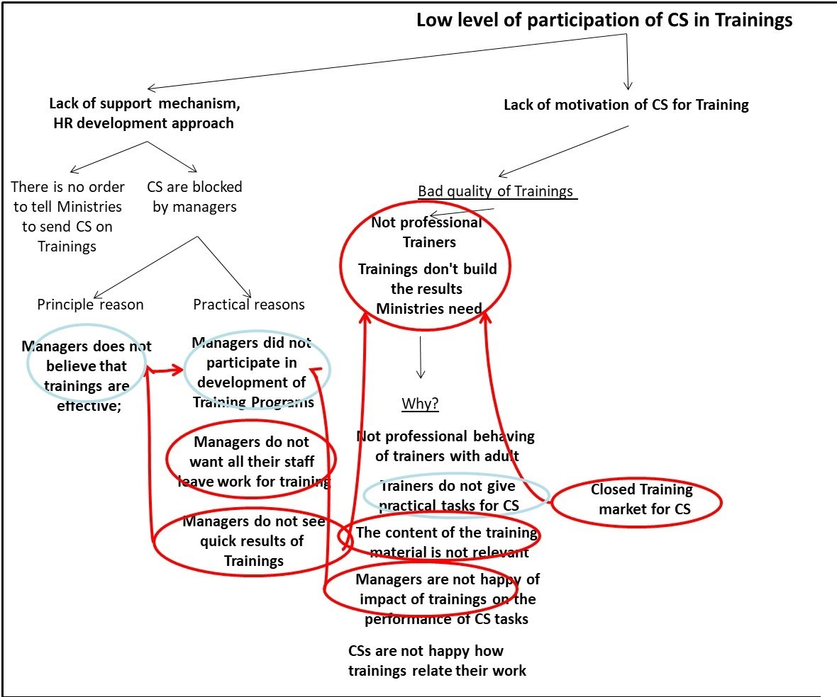

Чи має уряд виправити це?

Тепер, коли ми знаємо, у чому полягає проблема, нам потрібно визначити, чи є уряд відповідною організацією за її вирішення.

Уряд не повинен автоматично припускати, що він повинен вирішити проблему:
- Політика вимагає часу для розробки, схвалення та реалізації, і проблема, може зникнути перед реалізацією політики.
- Уряд має усвідомлювати, що на місцевому рівні (область, район, населений пункт) проблеми можуть бути вирішені краще – принцип субсидіарності.
- Іноді проблеми краще вирішуються через приватний сектор (бізнес) або неурядові організації чи громадянське суспільство з державною допомогою або без неї.

Яка частина аналізу проблем повинна бути у пропозиції політики?
- Проблема (дуже короткий опис);
- Основні причини проблеми;
- Основні причини виникнення проблеми;
- Динаміка того, як кореневі та супутні причини створюють проблему (оглядово).
- Короткий розділ з наведеними вище елементами дасть змогу Уряду добре зрозуміти проблему, на вирішення якої націлені запропоновані варіанти політики.

Які аспекти аналізу проблем можуть бути включені в додаток?
- Історичні аспекти проблеми;
- Детальний аналіз проблеми;
- Зображення дерева проблем;
- Причини проблеми, що були відхилені (та пояснення чому);
- Чому уряд повинен вирішити цю проблему (чи ні)?
- Список людей, з якими консультувалися при аналізі проблем;
- Процес аналізу проблем.

“ГЕНЕРУВАННЯ ВАРІАНТІВ ПОЛІТИКИ”

“GENERATING POLICY OPTIONS”

Що таке варіанти політики?

Варіанти політики - це різні рішення для досягнення мети політики.

Варіант політики - це добре вивчений попередній огляд того, що може бути досягнено завдяки різним варіантам політики, яким чином це можливо досягти і що необхідно для досягнення цього.

Варіанти політики призначені для представлення вибору Уряду.

Варіанти політики потребують подальшої розробки після схвалення КАБМІНом перед тим, як вони будуть готові до впровадження.

Генерування варіантів політики

Варіанти політики можуть бути сформовані за допомогою методу завдань дерева цілей та мозкового штурму з групою відповідних експертів та представників залучених організацій.

Це може призвести до створення безлічі можливих рішень, при цьому більше 2 чи 3 рішень можуть претендувати на розробку політичної пропозиції.

З цієї низки можливих варіантів політики слід зробити вибір, що означатиме, що багато варіантів політики не будуть розроблені чи навіть будуть відкинуті.

Перетворення дерева проблем: перетворення проблем у цілі

Уявімо, що ми вирішуємо всі проблеми, виявлені в аналізі проблем.

Ми робимо це, беручи проблему і переписуючи її так, наче вона вже вирішена.

Проблема: Низький рівень участі державних службовців у тренінгах.

Необхідно просто переписати так, неаче проблема була вирішена.

Результат: Високий рівень участі державних службовців у тренінгах.

Те, що ви зараз маєте, - це мета знайти рішення проблеми. Це результат, якого ми хочемо досягти стосовно цієї проблеми.

Зараз наступним питанням є: "яким чином ми це робимо?"

Приклад дерева цілей:

перетворення дерева проблем у дерево цілей

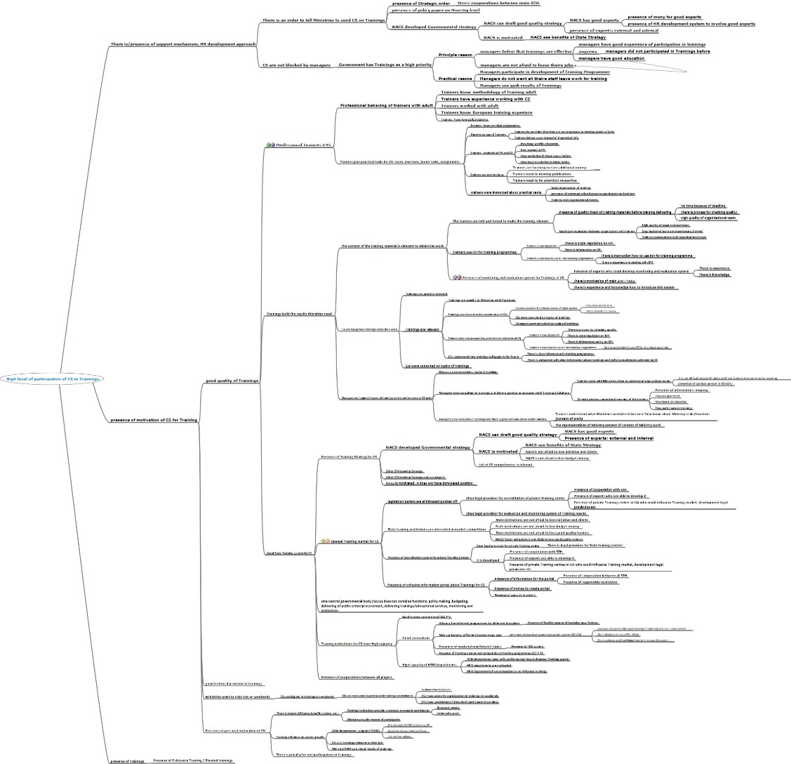

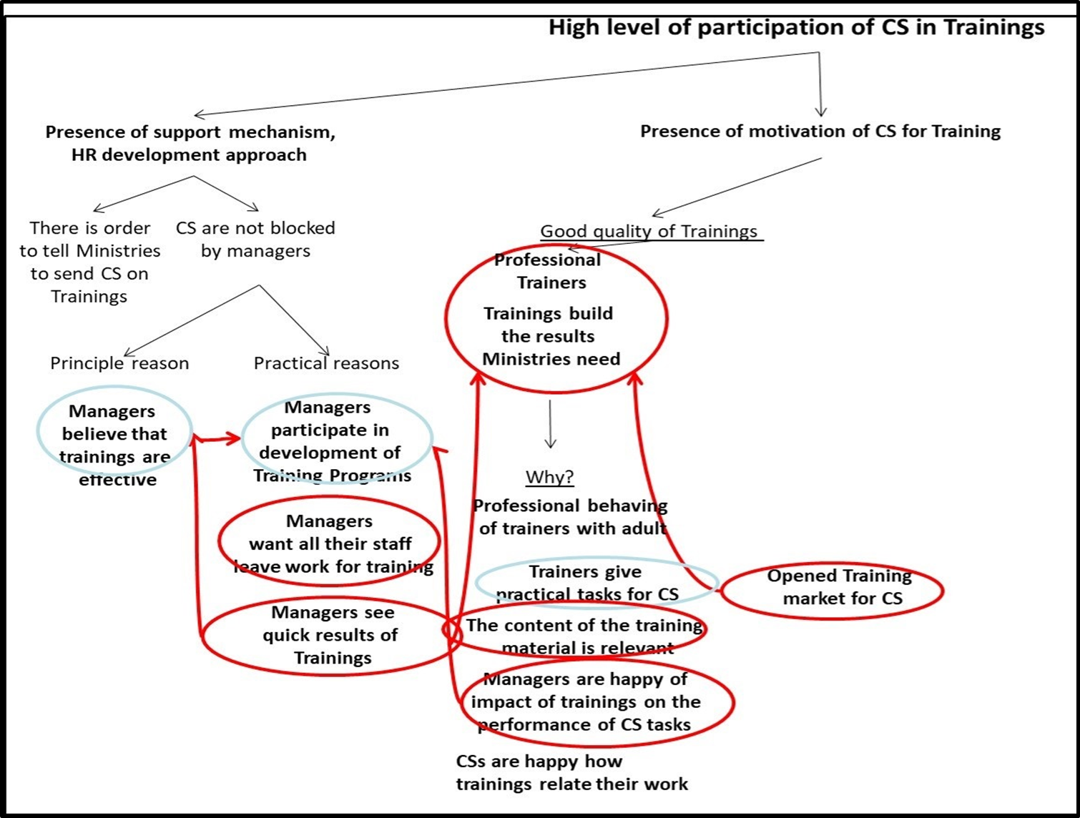

Як досягти цих цілей?

Тепер, коли у нас є дерево цілей, ми повинні зосередитися на тому, яким чином ми можемо по-справжньому досягти цих цілей.

Генерування різних варіантів вимагає поєднання аналізу та мозкового штурму.

По-перше, аналіз дасть вам краще розуміння мети, розгляду її з різних точок зору та визначення ключових аспектів рішення.

Група експертів може використовувати техніку мозкового штурму для створення різних підходів до досягнення мети, заснованих на початковому аналізі.

Приклад генерації варіантів політики

Мета - "Висока якість тренінгів для ДС"

Аналіз: що це означає?
- Тренінги відповідають потребам міністерств, їх проводят кваліфіковані тренери.
- Тренінги мають розроблятись відповідно до результатів аналізу тренінгових потреб на базі функціонального аналізу міністерств та ключових професійних індикаторів. Важливу роль тут відіграє налагодження комунікації між міністерствами і тренінговими закладами, в середні міністерств та в самому тренінговому закладі.

Аналіз / Мозковий штурм: як ми можемо цього досягти?
- Ми можемо підвищувати професійний рівень тренерів, тобто провести тренінги для тренерів, куди залучити і керівництво міністерств.
- Зміст тренінгів розробляти відповідно до проведено аналізу тренінгових потреб, для чого необхідна тісна взаємодія з міністерствами.
- Тренінги розробляти суто практичними для розвитку навиків і компетенцій, а не для надання інформації, для цього необхідно сформулювати конкретні вимоги тренерам і забезпечити належний моніторинг та оцінювання їх роботи.
- Теми тренінгів мають бути сучасними і спрямованими на майбутнє.
- До участі в тренінгах необхідно залучати керівництво міністерств.

Приклад дерева цілей: створення варіантів політики

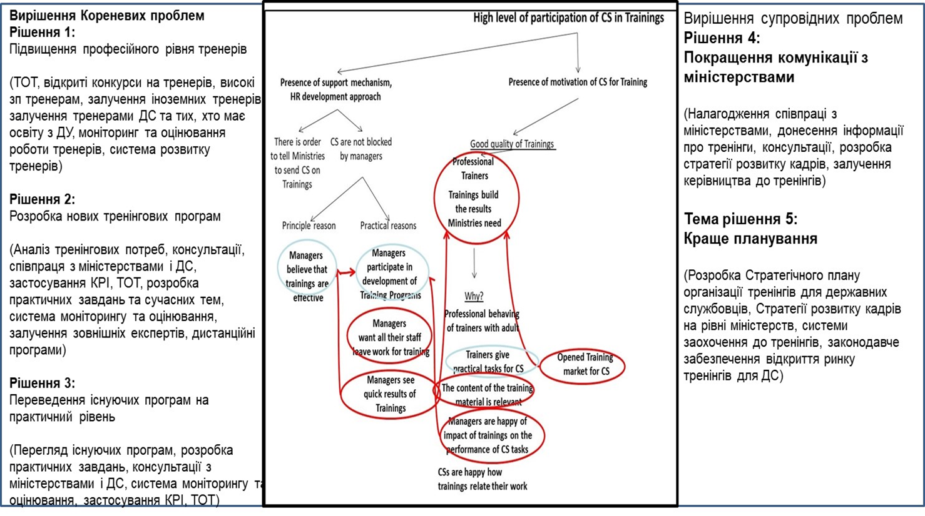

Інструменти політики та її впровадження

Інструменти політики – це різні засоби, які використовують уряди для досягнення бажаного результату політики. Наявність тих чи інших інструментів в уряду враховується під час розробки політики. Можна виділити наступні основні категорії інструментів:
- Політика через адвокацію: інформування, освіта, переконування інших діяти відповідним чином;
- Політика через гроші: використання сили витрат і податків для спонукання діяти певним чином;
- Політика через право: законодавство, регулювання, зобов’язання.
- Політика через прямі урядові дії: надання послуг урядом або укладення угоди з урядом.

Крім вибору інструментів політики, важливо визначитись одразу з організацією, яка буде надавати послуги, проводити заходи або впроваджувати інструменти політики. Це може бути урядова організація чи неурядова, з приватного сектору або ж кілька різних.

Вибір варіантів політики

Тепер ми створили безліч різних варіантів політики. Нам потрібні лише 2 або 3 варіанти політики аби включити їх до політичної пропозиції.

На цьому етапі варіанти політики є не набагато більшим, ніж базовими ідеями. Потрібна подальша переробка та розробка варіантів політики, але це вимагає часу та зусиль. Ми займаємося, прикладаємо до цього зусилля лише заради кількох варіантів політики, які, здається, є найбільш перспективними.

Це означає, що багато зі сформованих варіантів політики буде відкинуто після завершення процесу відбору та залишатимуться нерозробленими. Але ми повинні вести облік сформованих ідей політики, оскільки ці ідеї можуть знадобитися в майбутньому.

Критерії відбору

Вибір варіантів політики на початкових етапах залежить від відокремлення високопотенційних рішень від тих, які ними не є.

Ряд критеріїв, які можна використовувати для вибору/відкидання варіантів:
- Мета (з метою / занадто далеко від мети)
- Терміни (прийнятні/неприйнятні)
- Складність підходу (допустимий / розтягнутий)
- Логіка (тверда/сумнівна)
- Вартість (Прийнятна/проблемна)
- Правові аспекти (керовані/проблемні)
- Підтримка зацікавлених сторін (підтримка/відсутність)
- Порівняльні відмінності підходів до політики (різні / подібні)

Які з цих критеріїв релевантні залежать від основи політики. Рішення щодо вибору або відхилення варіантів часто приймаються на основі обмеженої інформації, тому що ніякі або деякі з варіантів політики не були вивчені на даний момент.

З необмеженими ресурсами може бути зроблений практично будь-який варіант політики, але насправді ми не маємо необмеженого часу, грошей, впливу, адміністративного та кадрового потенціалу. Хоча іноді політичні лідери готові багато що зробити заради амбіційного варіанту політики.

Запевнення в тому, що варіанти політики є різними

Метою різних варіантів є надання реального вибору для осіб, що приймають рішення. Існує багато способів зробити варіанти політики суттєво різними. Деякі приклади:
- Проміжок часу: короткостроковий / середньостроковий / довгостроковий
- Вирішення проблем: зменшення або усунення симптомів / структурних змін
- Фінанси: дешевий варіант / менш дешевий / дорогий
- Складність підходу: простий / нормальний / складний
- Територіальний: сільський / міський / обидва
- Правові наслідки: вимагає закону / вимагає регулювання або постанови / нічого не вимагає
- Цільова аудиторія: Вся/особлива група
- Ефект політики: низький/середній/високий

Існує більша кількість таких розбіжностей. Міністерство не зобов'язане використовувати будь-яку з них: вони повинні просто запропонувати варіанти, які, на їх думку, є найкращими. Однак, міністерство може схарактеризувати варіанти, наведені вище, оскільки це корисний короткотерміновий спосіб розумово організувати інформацію.

Характерні риси якісно виробленої політики
Вироблення політики це циклічний процес із переходом від визначення проблеми до оцінювання програми, що у свою чергу стає основою наступного етапу розроблення політики. Однак недостатньо сформований консенсус відображає реальну проблему гнучкості концепції вироблення політики, яка на практиці не має чітких правил.
Основою вироблених рішень повинні стати конкретні принципи, при цьому вони повинні застосовуватись незалежно від контексту.
Основна послідовність етапів циклу політики така:
• Виділення проблеми, основних причин її виникнення і пов’язаних із цим потреб з метою виявити обґрунтування для публічного політичного втручання (наприклад, у зв’язку з крахом ринку чи правління).
• Формування політичної відповіді за результатами ряду сценаріїв вирішення проблеми і задоволення потреб і сподівань зацікавлених сторін (громадян, бізнесу, публічних установ тощо), а також оцінювання варіантів з урахуванням усіх переваг і недоліків альтернативних підходів.
• Вибір бажаного рішення, зазвичай на рівні політичного чи вищого керівництва, коли це можливо — за результатами консультування із зацікавленими учасниками процесу, на яких безпосередньо вплинуть їх результати.
• Реалізація погодженої політики та її моніторинг як засобу управління задля відстеження її ефективності та вимірювання прогресу відносно плану, у тому числі усіх відхилень чи непередбачених результатів.
• У підсумку — оцінювання політики, щоб пересвідчитись у її успішності при вирішенні первинної проблеми і задоволення потреб зацікавлених сторін. У разі підтвердження таке оцінювання формує висновки для майбутніх втручань, а якщо це не так, то таке оцінювання визначає, чи не була початкова мета поглинена подальшими подіями, або рекомендує альтернативний напрямок дій для розроблення політики.
Цю традиційну модель вироблення політики подано нижче. Поширена думка про те, що це ідеалізоване бачення політичного процесу і що ця модель вважається ілюстративною.
Виділення проблеми (аналіз потреб)
Формування політики (встановлення цілей і оцінювання варіантів)
Оцінювання політики (встановлення факту вирішення проблеми)
Реалізація політики (перехід до дій і моніторинг процесу)
Прийняття рішень щодо політики (консультування і вибір напрямку дій)
Класична модель політичного циклу
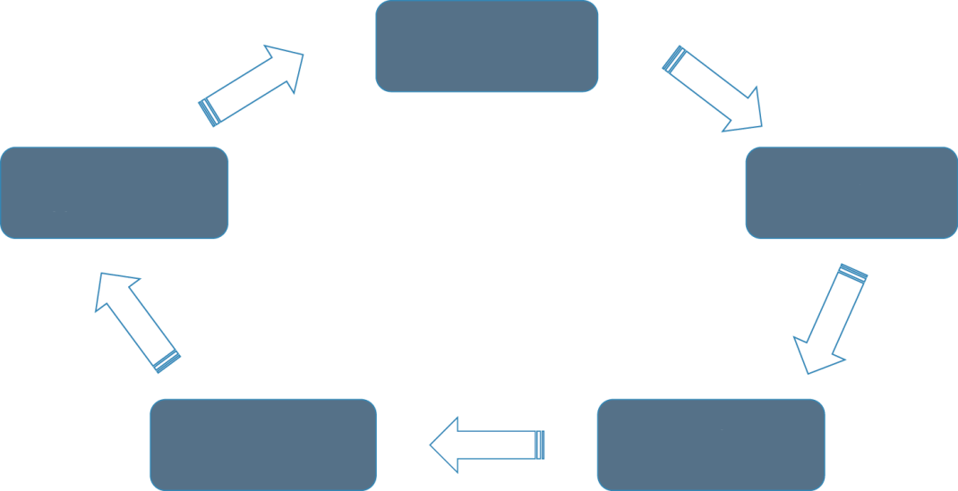
Насправді ж реальна ситуація зазвичай більш ускладнена та іноді має хаотичний характер:
- Адміністрації нечасто починають роботу з нуля. Ініціатива з розроблення політики може мати різне походження: політичні зобов’язання, що були прийняті під час виборів; пріоритети окремих обраних чиновників (міністрів, мерів тощо), зобов’язання в рамках директив ЄС та міжнародних угод, публічний тиск, кризи, нові підходи до старих політичних проблем, лобіювання з боку аналітичних центрів та об’єднань і багато інших. Це — «основа» виділення проблеми і формування політики в рамках існуючого набору ідей і пропозицій. Коли це дозволено, адміністрації також можуть висловити бажання оскаржити ці припущення в інтересах твердості політики, але у будь-якому випадку вони майже повсякчас представляють початкові параметри вироблення політики.
- За традиційною моделлю вироблення політики є лінійним, послідовним і цілісним процесом, а в адміністрацій є достатньо часу на реалізацію кожного етапу і обдумування результатів, перш ніж перейти до наступного етапу. На практиці етапи цього циклу взаємозалежні, можуть відбуватись одночасно, і часто їх неможливо відокремити один від одного. Обрані чиновники на будь-якому (наддержавному, державному, регіональному чи місцевому) рівні можуть потребувати чи звертатися по всеосяжні та одночасні політичні поради — готові рішення для існуючих проблем, у тому числі сценарії й рекомендації щодо найкращих варіантів дій, а також пропозиція щодо здійснення політики включно з бюджетом і відповідальним органом. Прийняття рішень щодо політики може включати ряд пунктів, що перебувають у постійному розвитку — із цілями, можливими діями та бажаним варіантом (часто разом із пошуками нових ресурсів або інформації).
- Виробники політики можуть приймати рішення без змоги ретельно розглядати усі доступні варіанти через обмеженість інформації або часові обмеження. У багатьох випадках рішення оголошується на основі політичної доцільності або парламентських графіків, а не за об’єктивними доказами. У реальному світі непередбачуваних подій і цілодобового потоку новин виробники рішень іноді змушені швидко робити політичні заяви у відповідь на виникнення нових ситуацій.
- Ланцюжок гіпотетичних подій у політичному циклі легко порушити — особливо у разі зміни правління. Навіть в умовах стабільного правління обрані чиновники можуть піти з посади за власним бажанням, вийти на пенсію або їх можуть замінити до того, як політика буде повністю сформована, реалізована або оцінена. Їхні наступники можуть забажати змінити напрям політики. Оцінювання часто мало пов’язане із самим процесом вироблення політики — ним або повністю нехтують, або ж результати надходять запізно для того, щоб вплинути на зміни у розробленні політики.
- Більш поширеним є моніторинг, однак він не обов’язково має систематичний характер (із використанням базових ліній, індикаторів та орієнтирів). Якщо політика не спрацьовує, обрані чиновники часто дізнаються про це через такі менш офіційні канали як громадська думка, критичні ЗМІ та бізнес-лобі. Поки що будь-який з етапів вироблення політики — цілі, варіанти здійснення, фактична реалізація — може бути скоригований або навіть відкинутий.
Тому сам процес вироблення політики може бути ретельним або неповноцінним (і мати усі проміжні ознаки). На етапі реалізації навіть найкращі наміри можуть породжувати «погану політику» з неочікуваними і несприятливими наслідками. Через мінливість обставин вироблення політики ніколи не перетвориться на точну науку. У динамічному світі перед публічними адміністраціями постає необхідність робити складний вибір, вони повинні знаходити вихід зі складних ситуацій та управляти невизначеностями, що є наслідком складних ситуацій (див. далі). Політика перебуває під впливом екзогенних чинників, а її наслідки не можна прогнозувати точно, що спонукає до застосування принципу прийняття і адаптації. Адміністрації повинні зосереджувати увагу на першочергових цілях і завжди тримати їх у полі зору з готовністю реагувати на події у процесі їх виникнення та бажанням адаптувати відповідним чином короткострокові оперативні задачі і дії.
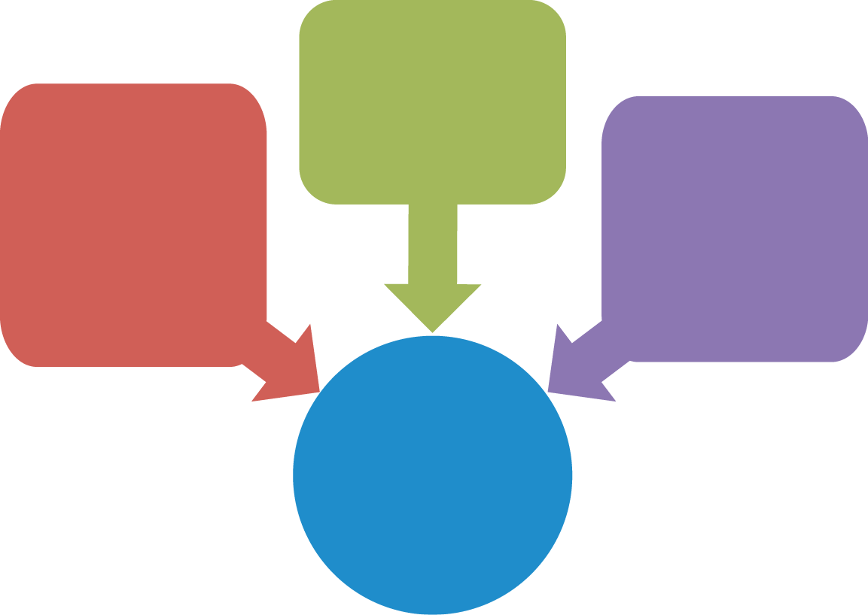
Вироблення публічної політики неможливо відділити від демократичного мандату, тому розробка політики повинна відображати взаємозв’язок між політичними пріоритетами обраних чиновників (на державному, регіональному чи місцевому рівні) та «мудрими порадами» призначених чиновників (державних службовців). З урахуванням важливості політики, заснованої на фактах, це вимагає поєднання чіткої стратегії та лідерства політиків зі збалансованими і професійними порадами адміністрації.
Складні сценарії пов’язані з масштабами проблеми, або ж із заплутаним і ризиковим процесом (наприклад, міжнародні переговори)
Складні ситуації пов’язані з широким розподілом повноважень, високою мірою взаємозалежності та непередбачуваністю деяких нових характеристик (це, наприклад, зміни клімату)
Складний вибір пов’язаний із конфліктами точок зору та інтересів, браком інформації, ресурсів, потенціалу, політичної волі або часу (наприклад, в умовах скорочення дефіциту)
Добре врядування

Від підходів до цілей
Формування політики: мета та стратегічні цілі
Коли генеруються варіанти політики, з всіх наявних варіантів обирають 2 чи 3, які, на відміну від інших, будуть здатні досягти запланованих стратегічних цілей або наблизитись до них. Після підготовки підходів для кожного варіанти, а також їх деталізації, досліджень та аналізу, ми можемо точніше визначити мету кожного варіанту політики.
Для кожного варіанту політики потрібно написати мету, яка співвідноситься с цілями реформи загалом. Це має бути включено в аналітичний документ не більше, ніж в 5 реченнях.
- Варіанти політики – це різні вирішення однієї і тієї ж самої проблеми
- Незважаючи на те, що існує загальна мета, для якої розробляються політика (наприклад, 20% покращення якості тренінгів чи підвищення участі ДС в тренінгах), не всі варіанти будуть здатні однаково досягти поставленого завдання: якісь покажуть кращі результати, якісь – гірші.
- Це – нормальне явище, коли є різні варіанти; це також призводить до того, що часто стратегічна ціль не встановлюється до тих пір, поки Кабінет Міністрів не затвердить один з варіантів
- Цілі кожного варіанту політики все ж мають бути варіацією на тему стратегічної цілі

Визначаємо мету кожного варіанту політики
Процедура:
- Переглянути стратегічну ціль та визначити головні елементи політики (загальну ціль та головні критерії)
- Порівняти підходи різних варіантів політик щодо досягнення стратегічної цілі, та визначити наскільки кожен варіант здатний виконати цю ціль, і яким критеріям він відповідає
- Занотувати всі відхилення від стратегічної цілі та спрогнозувати ймовірні наслідки кожного варіанту політики
- Сформулювати мету кожного варіанту політики, змінюючи окремі слова, фрази та/або цифри стратегічної цілі до тих пір, поки вона відобразить, що може бути досягнуто в реальності
Як сформулювати мету?
- Запишіть, для чого призначена політика
- Ознайомтесь з контекстом, щоб виокремити головні аспекти цілі впровадження політики
- Поставте уточнюючі запитання:
  - Що, як, де, хто, коли, скільки, як часто, та ін.
- Об´єднайте всі елементи і сформулюйте мету політики
- Додайте критерії виконання завдання

Приклад покрокового формулювання мети політики
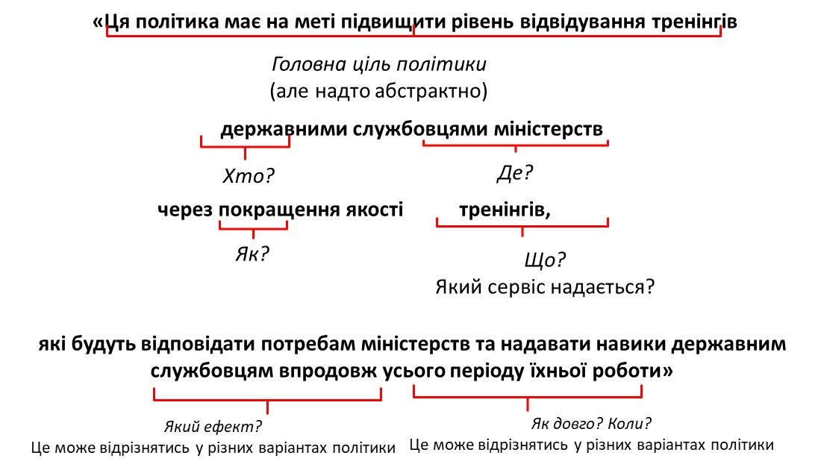

Додаємо критерії виконання завдання
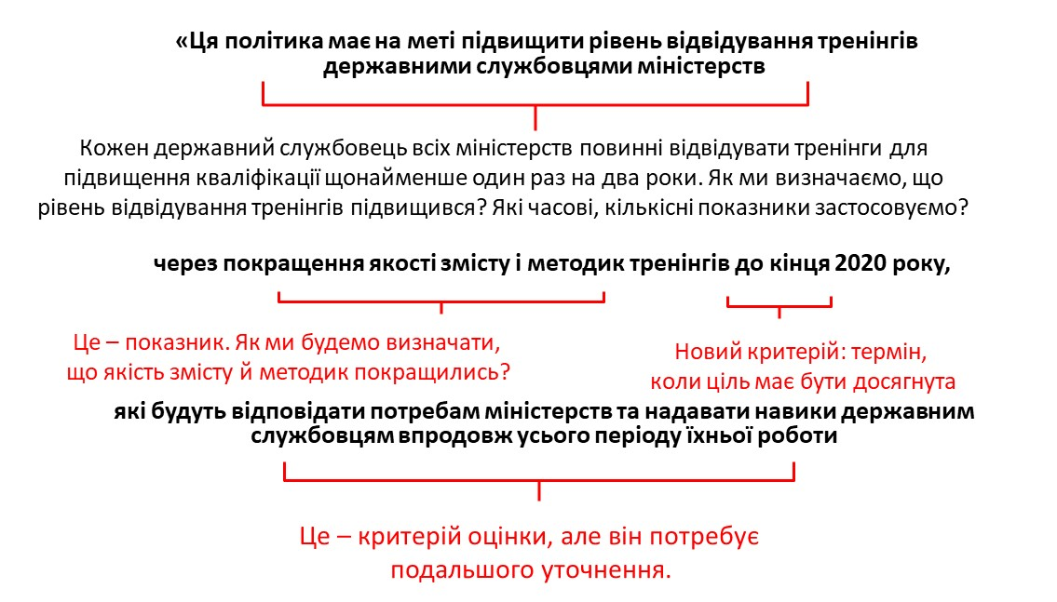

Мета для варіанту 1:
Вдосконалити нормативно-правове забезпечення тренінгових послуг для ДС
- Цей варіант політики має на меті деталізувати ЗУ «Про державну службу» (2016) та доповнити Типове Положення НАДС № 438/28568, які зобов’язують ДС підвищувати кваліфікацію, однак не дають їм права обирати надавачів тренінгових послуг, встановлюють, що керівник, а не сам ДС, приймає рішення щодо підвищення кваліфікації його підлеглих, а також не передбачають відповідальності служб управління персоналом (СлУП) і керівника щодо незабезпечення виконання цього обов’язку.
- Мета буде досягнута через внесення впродовж 2019-2020 рр змін до згаданих ЗУ та Типового положення, якими:
  - Буде надано право ДС обирати надавачів тренінгових послуг;
  - Буде надано НАДС приймати рішення щодо необхідності підвищення кваліфікації ДС на основі щорічного оцінювання результатів службової діяльності ДС;
  - Встановлено відповідальність служб управління персоналом і керівників у разі незабезпечення ДС підвищенням кваліфікації;
  - Передбачено механізми фінансового та кар’єрного заохочення підвищення кваліфікації.
Цей варіант передбачить механізм контролю за роботою служб управління персоналом та керівним персоналом щодо забезпечення розвитку кадрів міністерств, зокрема участі ДС у тренінгах, а також спростить доступ недержавних надавачів тренінгових послуг, підвищить особисту мотивацію ДС. Наявність конкуренції на ринку сприятиме вдосконаленню тренінгових програм та тренерів в перспективі на 3-5 років.

Ціль для варіанту 1:
питання та критерії вимірювання

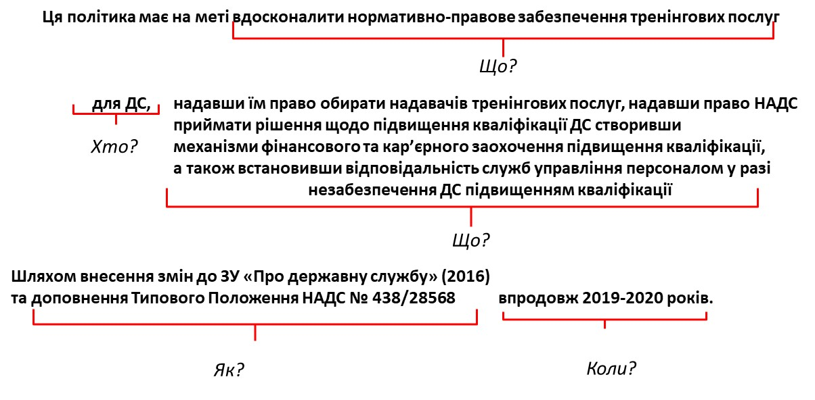

Мета варіанту 2:
виведення ринку тренінгів з державного в приватний сектор
- Для досягнення цієї мети необхідно прийняти впродовж 2019 року відповідні НПА КМУ, які виведуть з ринку тренінгів державних і комунальних надавачів послуг та спростять систему акредитації, сертифікації та ліцензування тренінгових центрів приватного сектору для ДС.
- Цей варіант має збільшити конкурецію серед тренерів та тренінгових закладів з 0% до 100%
- Спростить залучення іноземних тренерів з передовим досвідом і знаннями
- Ліквідує корупцію в державних і комунальних структурах
- Зніме напругу між ключовими гравцями вітчизняного державного сектору підвищення кваліфікації НАДС і НАДУ

Мета варіанту 2:
питання та критерії вимірювання
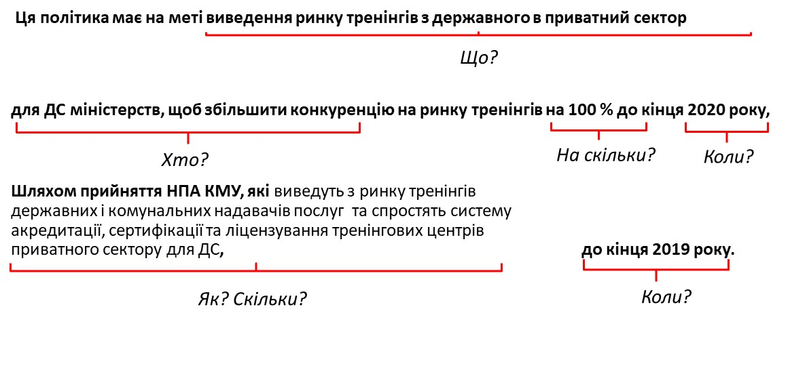
Мета варіанту 3:
Підвищення професійного рівня тренерів
Досягнення цієї мети передбачає:
  - Розробку і впровадження тренінговими центрами комплексної програми розвитку тренерів, яка охоплюватиме: проведення тренінгів для тренерів щомісяця по 5 днів, закордонне стажування один раз на два роки, стажування тренерів в органах управління один раз на два роки; Наявність такої програми має бути умовою ліцензування тренінгових центрів; підвищення кваліфікації, отримання закордонного досвіду та стажування в органах ДУ має забезпечуватись тренінговими центрами та тренерами самостійно;
- Проведення тренінговими центрами відкритих конкурсів тренерів з 2019 року; умови конкурсу визначаються тренінговими центрами;
  - Запровадження високого рівня ЗП тренерам впродовж 2019-2020 рр в кілька етапів, залежно від їх витребуваності на ринку тренінгів, щонайменше у 4 рази більше існуючого для кандидатів, докторів наук та у разі відсутності звання; має бути врегульовано на рівні КМУ; оплата має відбуватись з бюджету тренінгових центрів;
- Залучення іноземних тренерів до кожного тренінгу, здійснюється тренінговими центрами в межах власних бюджетних коштів;
  - Залучення тренерами ДС та тих, хто має освіту з ДУ; здійснюється тренінговими центрами в межах власних коштів;
  - Розробку і впровадження до 2019 року систем моніторингу та оцінювання роботи тренерів; здійснюється тренінговими центрами, узгоджується з НАДС, затверджується КМУ;
- Цей варіант має привести впродовж 1-2 років на ринок тренінгів найбільш кваліфікованих тренерів, які розуміються на ДС і ДУ, а також іноземних експертів, які забезпечать поширення іноземного досвіду роботи ДС; підвищить конкуренцію на ринку тренінгів.
Ціль для варіанту 3:
питання та критерії вимірювання

Мета варіанту 4:
Покращення співпраці з міністерствами
Для впровадження цього варіанту необхідно розробити і прийняти до середини 2019 р стратегію розвитку кадрів міністерств на три роки. Рамкову стратегію має розробити і затвердити НАДС впродовж 1-го місяця, кожне міністерство має затвердити власні стратегії і подати в НАДС та оприлюднити їх впродовж 3-х місяців;
Цей варіант також передбачає розробку і впровадження до кінця 2019 р тренінговими центрами і НАДС системи моніторингу та оцінювання тренінгових програм і тренерів.
Участь міністерств (СлУП та керівних кадрів) у розробці тренінгів, донесення інформації про наявні тренінги мають стати обов’язковими для СлУП та керівних кадрів, що сприятиме участі ДС у тренінгах та підвищенню мотивації керівників щодо участі їх підлеглих у тренінгах.
Цей варіант політики дасть можливість розробити нові тренінгові програми та перевести існуючі на практичний рівень впродовж 3 місяців після прийняття стратегій розвитку кадрів міністерств.

Ціль для варіанту 4:
питання та критерії вимірювання
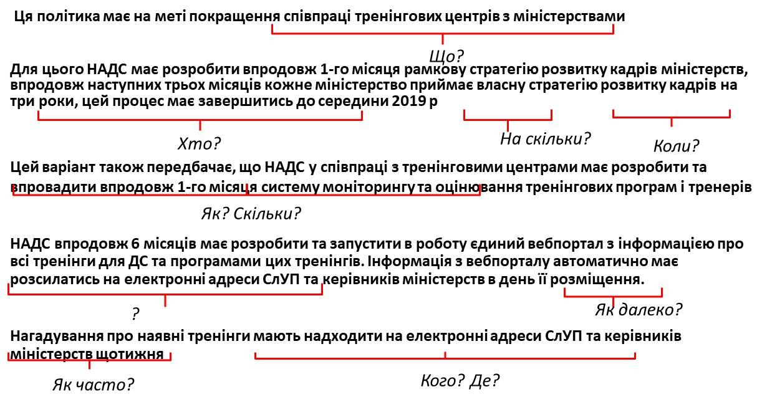

ЩО ПОТРІБНО ДЛЯ РОЗРОБКИ ВАРІАНТУ ПОЛІТИКИ?
Адміністративні ресурси міністерства
Наявні варіанти політики будуть різнитись в залежності від кількості наявних кадрів та часу, які потрібні на імплементацію. Така потреба у часі та кадрах може бути тимчасовою (тільки під час імплементації реформи) або структурною (для підтримки реформи). Час і кадрові ресурси є обмеженими, тому складні або надто інтенсивні варіанти політики можуть бути дуже складними (або неможливо) для адміністрування. Саме через це потрібно звертати особливу увагу на кадрові ресурси та час, що є в наявності
Бюджетне навантаження
Кожний варіант політики має певні бюджетні потреби. В них включають:
- Вартість початкової імплементації: пакет інвестицій чи розрахунок видатків, які потрібні для того, щоб вперше запустити реформу
- Вартість підтримки: поточні видатки чи пакет інвестицій, які потрібні для структурної підтримки політики щорічно (заробітні плати, технічне обслуговування, ремонт, загальні витрати і та ін.)
- Індикатор того, що дана політика може бути профінансована: чи може ця політика бути повністю чи частково покритою з існуючого бюджету, чи потрібен додатковий бюджет; за потреби, де знайти додаткові кошти?
Законодавчі потреби на впровадження політики
У кожного варіанту політики треба окремо наголосити на потребах у законодавстві. Це стосується того, чи потрібно прийняти новий закон, підписати міжнародний договір, чи впровадити нове розпорядження.
Ця секція в аналітичному документі має чітко пояснювати, які ключові моменти потребують нового закону чи порядку. Законодавчі потреби з´являються не завжди. Але в разі потреби нового законодавства, треба мати на увазі, що процес їх розробки та імплементації може бути дуже довгим через залучення парламенту. Кабінет Міністрів має вирішити, чи готові вони впроваджувати варіант, який потребує такого складного процесу.
Залучення зацікавлених сторін
Деякі варіанти потребуватимуть близького співробітництва з іншими урядовими/неурядовими організаціями. План, який визначає завдання, ресурси, вклади та результати, що очікуються від кожної зацікавленої сторони, має бути підготовлений як супроводжуючий документ. Для кожного варіанту такий план має бути свій, за можливості, з різними зацікавленими сторонами.
Якщо сторони мають бути залучені активно, то такий аналітичний документ має містити підписи цих сторін, що позначає, що вони погоджуються брати участь у впровадженні політики згідно плану.

АНАЛІЗ ПЕРЕВАГ ТА НЕДОЛІКІВ ВАРІАНТІВ ПОЛІТИКИ
Навіщо проводити аналіз переваг та недоліків?
Рідкість, коли варіант політики має лише хороші сторони; більшість варіантів має позитивні та негативні фактори. Уряд може винести добре проінформоване рішення лише тоді, коли відомо, що добре і що погано в запропонованому варіанті. Часто в державній політиці стається так, що уряд має йти на поступки, вирішуючи, яке співвідношення позитивних та негативних факторів є прийнятним
Для міністерств надзвичайно важливо бути чесними щодо позитивних та негативних аспектів, і не намагатись маніпулювати інформацією так, щоб вплинути на рішення уряду.
Як визначити позитивні та негативні фактори?
У кожного варіанту політики є сильні та слабкі сторони, які можуть бути виявлені в процесі порівняння. Для цього є дві можливості: варіанти політики можна співвіднести до стратегічної цілі та/або будь-яких попередніх вимог та вказівок; або можна порівняти однин варіант політики з іншими
Ті ж самі категорії, які використовуються для вибору варіантів політики, можуть використовуватись для того, щоб генерувати та порівнювати переваги та недоліки
  - Досягнення цілі (точне/менше/більше)
  - Час на впровадження (результати швидкі/згідно норми/повільніші)
  - Вартість (висока/середня/низька)
  - Потрібні законодавчі інструменти (потреба у законі/акті чи порядку/декілька видів законодавства/жодних потреб)
  - Підтримка сторін (велика/достатня/недостатня)
  - Складність підходу (процес імплементації легкий/середній/важкий, такий що потребує додаткової уваги)
  - Ймовірність успіху (за думкою експертів, наскільки ймовірним є успіх імплементації політики)
  - Рівень контроверсійності (деякі варіанти можуть спричинити політичні дебати/ деякі є нейтральними темами)
Також, міністерство має право надати пріоритет одному з варіантів. Звичайно, в такому разі уряд має пояснити, чому було прийнято саме таке рішення. Пояснення має посилатись на висновки та аналіз, який містився у попередніх секціях проекту, а також контекст прийняття рішення, огляд всіх опцій, та порівняльний аналіз. Уряд може все ще обрати інший варіант, навіть якщо він не має пріоритету від міністерства.

Переваги та недоліки варіанту 1

Переваги:
- Підвищить мотивацію ДС до участі в тренінгах (очікувано на 40%), оскільки вони зможуть самостійно обирати тренінги та надавачів послуг; це позитивно вплине на якість державних послуг;
- Підвищить відповідальність СлУП та керівників за підготовку та розвиток кадрів, що сприятиме збільшенню кількості ДС, які беруть участь в тренінгах очікувано на 20%; таким чином підвищення кваліфікації ДС відбуватиметься не на папері, а реально;
- Сприятиме підвищенню конкуренції серед ДС, тренерів та тренінгових центрів;
- Не призведе до зростання бюджетних витрат;
- Сприятиме зменшенню корупції.

Недоліки:
- Потребує нормотворчої роботи, що займає багато часу - 2-3 рр;
- Важко подолати спротив основних стейкхолдерів, які є монополістами надання тренінгових послуг в Україні, тому варіант може взагалі не досягти мети;
- Сприятиме виведенню коштів з бюджетного в приватний сектор;
- В перші кілька років збільшить навантаження на СлУП, оскільки їм доведеться опрацьовувати додаткові запити ДС щодо участі в тренінгах.

Переваги та недоліки варіанту 2

Переваги:
- Збільшить конкурецію серед тренерів та тренінгових закладів з 0% до 100%; що приведе до вдосконалення навчальних програм, їх актуалізації тощо;
- Спростить залучення іноземних тренерів з передовим досвідом і знаннями;
- Ліквідує корупцію в державних і комунальних структурах;
- Зніме напругу між ключовими гравцями вітчизняного державного сектору підвищення кваліфікації НАДС і НАДУ

Недоліки:
- НАДС і НАДУ не підтримують таких змін; це може привести до того, що мета взагалі, може бути не досягнута;
- Відсутність розвиненого ринку тренінгових послуг в приватному сектору;

Переваги та недоліки варіанту 3

Переваги:
- Наявність висококваліфікованих тренерів через 1-2 роки, які мають закордонний досвід та досвід роботи в органах ДУ; підвищення кваліфікації, отримання закордонного досвіду та стажування в органах ДУ має забезпечуватись тренінговими центрами та тренерами самостійно;
- Підвищена ЗП тренерам; що приведе до збільшення конкуренції серед тренерів і, відповідно, покращення якості їх тренінгових матеріалів;
- Збільшення кількості іноземних тренерів впродовж перших двох років очікувано на 75%; залучення відбувається на конкурсній основі тренінговими центрами;
- Збільшення кількості ДС та тих, хто має освіту з ДУ, які працюють тренерами;
- Наявність різних систем моніторингу та оцінювання роботи тренерів, розроблених тренінговими центрами у співпраці з НАДС;
- Залучення в тренінговий сектор приватних коштів (зокрема, за рахунок того, що тренінгові центри самостійно будуть оплачувати обладнання, приміщення тощо);

Недоліки:
- Наразі, ми не маємо Тренінгів для тренерів та тренерів для тренерів, а також системи підготовки тренері для ДС; їх підготовка може забрати близько 1-1,5 року;
- Відтік коштів з державного сектору в приватний;
- Додаткове навантаження на НАДС у зв’язку із реформою; цей недолік може бути усунути за рахунок позбавлення НАДС невластивих функцій, як от, надання тренінгових послуг;
- Різке зростання витрат на ЗП тренерам; тому потребує додаткових витрат з бюджету

Переваги та недоліки варіанту 4

Переваги:
- СлУП та керівні кадри залучені до розробки тренінгів, вони знають про зміст тренінгів, мають у них зацікавленість, що сприятиме участі ДС у тренінгах та підвищенню мотивації керівників щодо участі їх підлеглих у тренінгах, застосуванню КРІ під час розробки тренінгів, розробці практичних завдань та сучасних тема також підвищить якість тренінгових програм та актуалізує їх
- СлУП та керівні кадри доносять інформацію про наявні тренінги для ДС, що сприятиме участі ДС у тренінгах.
- Покращення співпраці сприятиме проведенню якісного аналізу тренінгових потреб, консультаціям з зацікавленими сторонами;
- Відкритість інформації про наявні тренінги на сайтах НАДС, міністерств і тренінгових центрів;
- Може бути впроваджений досить швидко.

Недоліки:
- Потребує додаткових витрат з бюджету;
- Додаткове навантаження на керівні кадри і СлУП;
- Не передбачає запровадження вільного ринку тренінгів, тобто конкуренції;
- Не вирішує проблеми системно.

ЛОГІКА ПОЛІТИКИ
Ключовим показником якості гідного варіанту політики є його сильна логіка.
Логіка вибору політики показує логічний ланцюг, що зв'язує проблеми з причинами, а згодом - як ми можемо впливати на ці причини і як ми це зробимо.
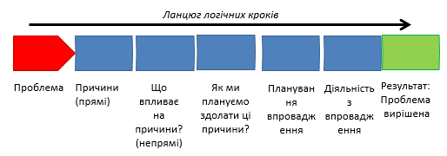
Логіка варіанту політики повинна бути переконливою, такою, де всі елементи взаємопов´язані.
Варіант політики має сенс, якщо діяльність та дії, що вживаються у політичному підході, працюють разом, щоб реально досягти цілі політики. Один крок повинен вести до наступного; кожен крок - це зв'язок у логічному ланцюзі.
Варіанти політики з сильною, реалістичною логікою мають набагато більший шанс успішно досягти цілей політики. Варіант політики стає більш надійним.
Сильна логіка полегшує написання переконливої пропозиції політики, що може завоювати схвалення КабМіну.
Сильна логіка полегшує підготовку детального плану реалізації варіанту політики, вибраного КабМіном.
Політика має бути побудована на послідовності пов'язаних кроків.
Логіка має перевірятись. Простим способом є перевірка процесу у зворотньому напрямку. Якщо це працює, ваша логіка сильна. Якщо це не спрацює, можливо, ви зробили деякі помилки у вашій логіці або підході.
Загальні помилки в логіці
- “O, ми це не брали до уваги”
Це є ознакою того, що розробники політики не взяли достатньо часу та зусиль, щоб обдумати свою політику. Вони пропустили логічні кроки або не змогли ретельно проаналізувати проблему. Політика є серйозною справою, і вона вимагає повної уваги та максимальних зусиль.
- “Звичайно, це є правильним, а те неправильним”
Це ознака перестрибування до висновків. Розробники політики зробили припущення, що вони знали, як і чому те чи інше є таким, як воно є, без проведення перевірки. Вони можуть бути праві, але якщо вони помиляються, політика не буде ефективною. Не думайте, що знаєте, переконайтеся.
- “Це зробить хтось інший”
Це також припущення. Розробники політики припускають, що інша організація це зробить, тому їм не потрібно нічого з цим робити. Це може бути правдою, але якщо інша організація не робить, як передбачається, або робить це по-іншому, політика буде в біді. Не думайте просто, що знаєте, переконайтеся.

Логіка вибору політики часто не виноситься в окремий пункт пропозицію уряду
Логіка варіантів політики, як правило, не розглядається в політиці, адже там немає розділу під назвою "Логіка". Тим не менш, важливо, щоб логічність дій відчувалась в політиці, адже уряд врахує це при винесенні рішення.
Ви можете виявляти логіку, шукаючи послідовності логічних кроків, які часто позначаються заголовками розділів або глав, включенням дерев проблем та цілей та використанням слів-маркерів і фраз, таких як: "через", "тому", "виконати це" і т. д.
- Policy logic: FORMULA

  - The problem is ___________ because of ______________therefore the solution is _______________, so that ______________to accomplish this:
    - Policy option 1
    - Policy option 2
    - Policy option 3

ЛОГІЧНА СХЕМА
Якщо ви маєте послідовний та логічний варіант політики, перетворення на логічну структуру є відносно простим. Логічна схема - це ієрархія логічних кроків, що йдуть від дій у нижній частині до цілі у верхній частині.
Колонка індикатора логічної структури повинна бути заповнена індикаторами прогресу (віхи) та рубіжами, які будуть потрібні для звітування до міністерства та КАБМІНу.

Матриця логічної рамки

 | Ланцюг результатів | Показники | Способи  перевірки | Припущення
Загальні цілі (Вплив):
Конкретні цілі (Підсумки):
Результати:
Заходи:

Висхідна логіка підходу логічної схеми
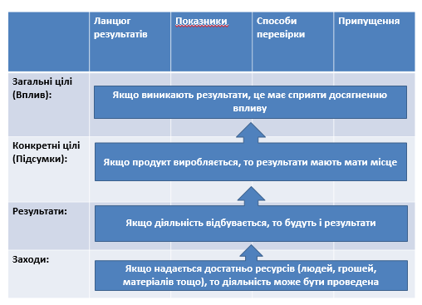

Заповнення матриці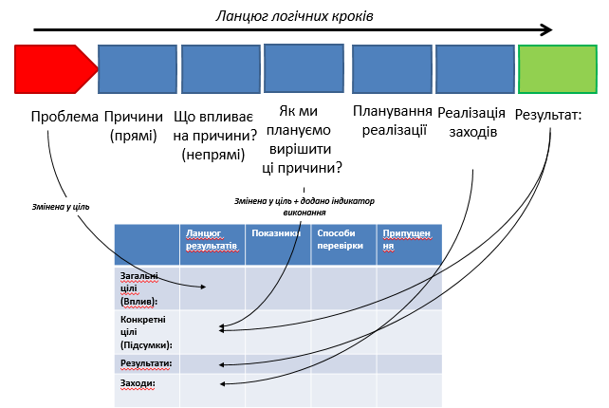

Оцінка регуляторного впливу
Як покращити якість політик в стадії їх розробки?
«Краще» - це:
- Ефективніше (досягнення цілі, на яку спрямована політика)
- Продуктивніше (зниження кількості потрібних ресурсів)
- Менш шкідливо (відносно інших галузей)
- Справедливіше (уникати дискримінаційних норм)
- Більш передбачувано (стабільні процеси, які майже не потребують змін)
- Більш координовано (співпрацювати з різними міністерствами)
- Більш прозоро (зменшити можливості для корупції)
- і т.ін.
Оцінка впливу
Оцінка впливу / ПРОГНОЗУВАННЯ – це важливий метод, що дозволяє покращити якість політик у стадії їх розробки. Це прогностичний метод (ex ante): тобто проводиться оцінка, яким буде вплив реформи, коли вона буде проведена. На основі отриманих даних можна покращити якість запропонованої реформи і обрати найоптимальніший варіант
Такий аналіз можна проводити відносно різних акторів та явищ – бізнес, групи громадян, захист персональних даних, довкілля і т.д. Також, увагу можна зосередити на порівнянні вартості реформи та оцінюванні її користі в разі впровадження. Це гарантує більш детальну інформацію, потрібну для прийняття рішення представниками влади
Оцінка регуляторного впливу (ОРВ)
«ОРВ – це системний підхід до критичного оцінювання позитивного і негативного впливу запропонованих і існуючих положень та нерегуляторних альтернатив» (ОЕСР)
Це – процес з визначеними інструментами та методами, які мають бути використані при розробці політики чи її оцінюванні. Даний процес можна використовувати по-різному. Кожний уряд вирішує для себе, як організовувати цей процес, та які елементи він має включати.
ОРВ вперше було впроваджено в 1946 році в контексті Акту про Адміністративні Процедури США. Цей інструмент було формалізовано в Штатах в 1970-х для оцінки впливу інфляції. З плином часу, цей інструмент був запозичений багатьма країнами (серед них і деякі члени ОЕСР), і застосований до багатьох сфер.
Масштаб застосування ОРВ все збільшується. Зараз цей термін часто позначає пакет заходів, що покращують якість регуляторних інструментів. ЄС використовує ОРВ в рамках вказівок і інструментів пакету «Краще управління»
В Україні також використовують ОРВ, зокрема норми містяться у законодавстві:
- Закон України «Про засади державної регуляторної політики у сфері господарської діяльності»
- Регламент Кабінету Міністрів України: стаття 50.1 та 52.3.5 закликають до впровадження інструментів оцінки регуляторного впливу
- Додатки 4,8 та 9 Регламенту Кабінету Міністрів України також посилаються на ОРВ
Однак, лише ~3% всіх важливих законодавчих актів використовують ОРВ
Є велика кількість ресурсів щодо ОРВ:
  - http://rulemaking.worldbank.org/ria-documents
  - http://www.oecd.org/gov/regulatory-policy/ria.htm
  - https://ec.europa.eu/info/law/law-making-process/planning-and-proposing-law/impact-assessments_en
Навіщо уряд має витрачати час, зусилля та ресурси на проведення ОРВ?
Цей метод збільшує вірогідність отримання вдалих результатів, дозволяє перевірити існуючі пропозиції політики на їх якість, а також визначити альтернативи.
Також цей метод може використовуватись для лобіювання горизонтальних політичних змін або встановлення пріоритету щодо певних питань, може збалансувати зовнішній політичний тиск, що вимагає прийняття певної політики.
Також ОРВ допомагає оцінити ризики щодо певних груп громадян, бізнесу, на які вплине реформа, та дає сигнал про покращення методів розробки політичних рішень для громадського суспільства та іноземних партнерів.
Хто проводить ОРВ?
ОРВ проводиться організацією/департаментом, що займається розробкою політики. Певні елементи можуть потребувати залучення інших агенцій, якщо це міжгалузеве питання. Тим не менш, відповідальний функціональний департамент залишається головним розробником ОРВ, навіть якщо певні елементи цього процесу виконуються іншими акторами
Обмеження щодо використання ОРВ
Процеси ОРВ можуть потребувати значних зусиль, і тому можуть виникати обмеження на використання цього методу, незважаючи на його користь. Кількість фахівців, що мають досвід у виконанні ОРВ, або її частин, може бути дуже обмеженою, бюджет може бути відсутнім на те, щоб направити елементи ОРВ іншим підрозділам. Також, не завжди достатньо часу на виконання ОРВ.
Через це часто відбувається пропорційне ОРВ: більш широка оцінка для ключових законопроектів, та простіший процес для менш складних проблем
Рекомендації щодо організації ОРВ
Щоб провести ОРВ систематично, високоякісно, та відповідно до існуючих вимог, потрібно таке:
  - Офіційно затверджений порядок про проведення ОРВ, де написано, як і коли має проводитись така оцінка, а також є конкретні вказівки щодо аналізу вартості і користі та інших методів оцінювання політики
  - Натреновані фахівці міністерств, які знають, як виконувати ОРВ відповідно до існуючого порядку
  - Час та ресурси для міністерств на проведення ОРВ
  - Центр урядових інституцій (СКМУ), що здатний перевірити ОРВ, що виконані або замовлені
  - Механізм прийняття рішень для того, щоб оцінити результати ОРВ та вибрати один з варіантів вирішення проблеми
Базові елементи ОРВ
- Аналіз проблеми
- Пошук шляхів вирішення проблеми
- Залучення зацікавлених сторін
- Аналіз економічної ефективності
- Аналіз за багатьма критеріями
- Оцінка ризиків

АНАЛІЗ НА ОСНОВІ БАГАТЬОХ КРИТЕРІЇВ
Це метод порівняння різних політик на основі критеріїв, які є важливими для осіб, що приймають рішення з цього приводу. Він дозволяє порівнювати альтернативні варіанти більш систематично та структуровано. В результаті отримується рейтинг запропонованих політик, де найвищу позицію займатиме варіант, який найбільше відповідає запропонованим критеріям. Цей метод часто використовується додатково до аналізу вартості та користі. Для його проведення існує два основних підходи:
- Стандартний аналіз за багатьма критеріями оцінки: фокус на відповідності варіанту щодо кожного критерію (можуть бути виражені рейтингами, оцінками в чистому чи зваженому вигляді). Цей метод простіший для розуміння та застосування
  - У процесі аналізу за багатьма критеріями можна використовувати рейтинги. Наприклад, кожен варіант політики можна оцінювати від 1 до 5 балів, або позначати такими символами ++, +, +-, -, --, та ін.
  - Також можна надавати оцінку варіантам, наприклад 0-100 балів. Оцінка дозволяє порівнювати варіанти більш ефективно
  - Зважені значення можуть використовуватись, якщо одні критерії важливіші за інші
- Відсоток переваг: акцент на виробленні рейтингу політик через пріоритет, який покладається на кожен критерій.
  - Цей метод не компенсує погані показники за одним критерієм хорошими показниками того ж варіанту за іншими показниками
  - Цей метод більш придатний для більш складного порівняння варіантів вирішення проблем, наприклад, коли треба врахувати громадську підтримку чи політичну опозицію щодо одного чи декількох критеріїв
  - Метод відсотку переваг вимагає застосування і оцінок, і зважених значень.
Кроки аналізу за багатьма критеріями:
- Визначити контекст для прийняття рішення (які цілі аналізу?)
- Визначити варіанти (які варіанти будуть порівнюватись?)
- Визначити критерії для порівняння варіантів
- Оцінити кожен варіант щодо кожного критерію
- Зважити критерії, щоб відобразити їх відносну важливість для прийняття рішення
- Комбінувати зважені значення та оцінки кожного варіанту, щоб вивести загальні значення
- Оцінити результати
- Провести аналіз стабільності результатів відповідно змін у оцінках чи зважених значеннях

Приклад аналізу за багатьма критеріями (стандартний варіант, фокус на виконанні критерію, без оцінок та зважених значень)
Nr. | Ім’я кандидата | Участь у вступному тренінгу | володіння англ.м. | Готовий приділити часу | Викла-  дацький досвід | Досвід  на ДС, роки | Можливості навчати ДС
1 | A | + | Вільне | 40 | 100 | 0-3 | +
2 | B | + | Вільне | 30 | 100 | 3-5 | +
3 | C | + | Вільне | 40 | 100 | 0-3 | +
4 | D | + | Вільне | 40 | 0 | 5+ | --
5 | E | + | Середнє | 20 | 100 | 0-3 | -
6 | F | + | Вільне | 30 | 33 | 5+ | -
7 | G | + | Вільне | 40 | 0 | 3-5 | -
8 | H | + | Базове | 20 | 100 | 3-5 | +
9 | I | - | Вільне | 20 | 100 | 0 | +
10 | J | + | Базове | 40 | 100 | 5+ | +
11 | K | - | Середнє | 20 | 66 | 5+ | +
12 | L | - | Вільне | 30 | 0 | 3-5 | +
13 | M | - | Середнє | 30 | 0 | 5+ | +
14 | N | - | Вільне | 30 | 100 | 3-5 | +

Такий аналіз можна провести дуже швидко, але в даному прикладі складніше визначити, який з варіантів найкращий через відсутність інформації по важливості кожного критерія

Приклад аналізу за багатьма критеріями (стандартний варіант, оцінки та зважені значення)
Nr. | Ім’я кандидата | Участь у вступному тренінгу | Знання англ.м. | Готовий приділити часу, днів | Викла-  дацький досвід | Досвід  на ДС, роки | Можливості навчати ДС | Середній бал
1 | A | 100 | 100 | 100 | 5+ | 33 | 100 | 86,6
2 | B | 100 | 100 | 66 | 5+ | 66 | 100 | 84,7
3 | C | 100 | 100 | 100 | 5+ | 33 | 100 | 86,6
4 | D | 100 | 100 | 100 | 0 | 100 | 0 | 75
5 | E | 100 | 66 | 33 | 5+ | 33 | 0 | 48,05
6 | F | 100 | 100 | 66 | 0-1 | 100 | 0 | 69,8
7 | G | 100 | 100 | 100 | 0 | 66 | 0 | 68,2
8 | H | 100 | 33 | 33 | 5+ | 66 | 100 | 63,05
9 | I | 0 | 100 | 33 | 5+ | 0 | 100 | 53,25
10 | J | 100 | 33 | 100 | 5+ | 100 | 100 | 86,6
11 | K | 0 | 66 | 33 | 1-5 | 100 | 100 | 63,05
12 | L | 0 | 100 | 66 | 0 | 66 | 100 | 64,7
13 | M | 0 | 66 | 66 | 0 | 100 | 100 | 64,7
14 | N | 0 | 100 | 66 | 5+ | 66 | 100 | 74,7
 | Вага показника | 10 | 20 | 25 | 10 | 20 | 15 | 100

Зважені значення в сумі мають давати 100 Зважена оцінка
Один критерій може компенсувати оцінку за іншим

Rationale for weighing factors
Attended EBPPM course: having participated in the course as a participant provides understanding about the flow of the course; how the case study is used and how it is to conduct a case study as a participant. It makes the training of the trainer easier as there is fundamental and experienced understanding of the course that will need to be taught by the trainer. |  |  |  |  | Score legend: |  |  | No (0) |  |  | Yes (100)
English language fluency: this is only important for the ease of communication between the STE and the trainer to be. The courses that will be delivered by the trainers to be will be conducted in Ukrainian language and english is not needed for that. However, since project fundign is not available, we assumign that most of the time no translator is present and we need to rely on exisiting english language skills. |  |  |  |  | score legend: |  |  | None (0) |  |  | Basic (33) | Interm  ediate (66) | Advanced (100)
Time availability: this is time that the trainers to be wil need for reviewing the course materials, preparing their own cases and convertign these into course materials. The trainers-to-be would also have to update the curriculum to make the course materials more relevant to the Ukrainian situation. This will take a significant amount of time and if only very limited time is available,quality will likely drop. |  |  |  |  | Score legend: |  |  | 10 days(0) |  |  | 20 days (33) | 30 days (66) | 40days (100)
Previous training experience: having some experience in training others (civil servants or other adults) will make it more likely that somebody will have acquired some of the necessary skills to effectively delivered the EBPPM and to handle various audiences, including experience civil servants involved in policy making. |  |  |  |  | Score legend: |  |  | None (0) |  |  | 0-1 years (33) | 1-5 (66) | 5+ (100)
Years of experience in the civil service: having hands-on experience of how things work in the civil service is important context information for the delivery of the EBPPM. These are general years of expeience in the civil service and it does not need to be in policy makign or related functions. This will make it easier for the trainer to relate to the civil servants and their issues, questions and dilemmas. |  |  |  |  | Score legend: |  |  | None (0) |  |  | 0-3 (33) | 3-5 (66) | 5+ (100)
Opportunity to teach civil servants: this is the ultimate aim of the training, namely to build a cadre of trainers able to train civil servants or future civil servants in EBPPM. If trainers already have work or opportunity to train civil servants then there is a greater likelihood that the final result will be achieved. |  |  |  |  | Score legend: |  |  | No (0) |  |  | Yes (100)

Управління ризиками
Часто у процесі імплементації виникають труднощі, які спричиняють затримки, надмірне бюджетне навантаження, або ж повну зупинку процесу впровадження політики. Думати, що все буде йти за найкращим варіантом розвитку подій нереалістично
Також не можна покладатись на те, що «все якось вирішиться». Можливо, так і буде, але подібні затримки і труднощі коштують додаткових ресурсів, часу та зусиль; тому такі ситуації краще передбачати. Для того, щоб добре спланувати процес впровадження політики, треба передбачити, де можуть виникнути труднощі, та подумати, як з ними боротись. Це може бути зроблено не тільки в процесі планування, а і під час самої імплементації, що збільшує шанси на її успіх.
Що таке ризики?
Ризик = ймовірність виникнення х рівень наслідків
Ризики – це потенційні явища, що при появі можуть завадити, зупинити, чи спричинити будь-який негативний ефект на імплементацію політики. Ризики можуть з’являтись ззовні, або ж виникати через внутрішні аспекти організації, або як наслідки прийнятого рішення. Ризики можуть ще не виникнути, взагалі не виникнути, чи виникнути в майбутньому. Якщо вони виникають, то вони можуть мати різний рівень негативних наслідків
Елементи управління ризиками
Цей процес складається з декількох кроків:
  - Визначення ризиків: при перевірці плану впровадження, документи щодо розподілу роботи чи інші документи щодо імплементації політики можуть показати слабкі місця, де не все може піти за планом
  - Визначення впливу ризику на процес імплементації: які будуть наслідки того, якщо цей ризик з´явиться?
  - Ймовірність ризику: яка вірогідність появи ризику?
  - Аналіз ризику: комбінація впливу та ймовірності для кожного ризику + створення матриці ризиків
  - Плани усунення ризиків: чи ми можемо уникнути ризиків за допомогою певних дій? Чи можемо ми зменшити негативні наслідки, застосовуючи певні заходи? Які заходи можна використати?
Визначення ризиків
Є багато способів для визначення ризиків. Однак, треба зважати на те, що ці способи нерідко є обмеженими
- Розподіл ризиків у структурі: треба проаналізувати розподіл роботи по імплементації та проаналізувати кожен елемент, який може бути невиконаним
- Широкомасштабні методи для мозкового штурму, як PESTLE:
  - Political (політичні) - які політичні фактори можуть вплинути на справу?
  - Economic (економічні) – які економічні фактори можуть вплинути на справу?
  - Sociological (соціологічні) – які культурні аспекти можуть вплинути на справу?
  - Technological (технологічні) – які технологічні зміни можуть вплинути на справу?
  - Legal (юридичні) – які законодавчі акти (наявні чи в стадії розробки) можуть вплинути на справу?
  - Environmental (довкілля) – як довкілля може вплинути на справу?
- Спілкування з експертами з впровадження політик: фахівці можуть знати, де найчастіше з´являються проблеми, або де є помилки у структурі роботи
- Досвід подібних програм у минулому: можна спробувати зрозуміти і попередити проблеми, які виникали раніше
Ймовірність виникнення ризику
Не всі ризики мають однакову ймовірність виникнення. Ймовірність ризику – це оцінка можливості того, що щось відбудеться поза планом. Звичайно, передбачити майбутнє неможливо, але можна широко охарактеризувати такі події.
Досвідчені фахівці, які мали досвід у подібних проектах чи програмах, можуть виступати досить якісним ресурсом для оцінки вірогідності, але для більш точного результату рекомендовано використовувати змішані фокусні групи.
Вплив ризиків
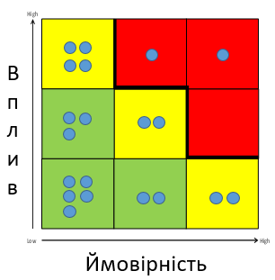
Не всі ризики мають однаковий рівень впливу в разі їх появи. Визначення рівня впливу може відбуватись за допомогою аналізу за якісними показниками, або в разі складних або надзвичайно важливих рішень, використовуючи кількісні методи оцінки
Використання матриці ризиків
- Визначені ризики (блакитні крапки) нанесені у матрицю ризиків (в даному випадку, 3х3)
- Ризики у зеленій області не складають сильної загрози для процесу імплементації
- Ризики на жовтому фоні мають сильний вплив на практичні аспекти процесу імплементації. Вони потребують обережного ставлення та наявності запасних варіантів
- Ризики на червоному фоні є настільки значними, що це може вимагати зміни підходу або плану впровадження політики. Ці ризики є критичними недоліками плану.

Заходи для пом’якшення ризиків
Замість того, щоб пасивно чекати на те, чи з’явиться ризик, чи ні, можна почати вживати заходи для того, щоб зменшити вірогідність або рівень впливу ризику в разі його появи.
Можна спробувати:
  - Прийняти ризик і його негативні наслідки
  - Передати ризик іншій особі/організації
  - Зменшити силу ризику через зменшення ймовірності його виникнення або прогнозованого рівня впливу
  - Уникнути ризик через повне виключення ймовірності його виникнення
Деякі методи пом’якшення ризиків
- Передача ризику: можна використати інших виконавців, передати виконання іншій організації або іншому рівню уряду, або ж приватній фірмі
- Обмеження ризику: стандартизація, планування запасних варіантів дій, створення буферу для зменшення негативних ефектів, моніторинг дій та заходів, методи координації та контролю, зменшення політичних впливів, зарезервований бюджет
- Уникнення ризику: зміна плану імплементації; скасування політики; зміна політики, щоб уникнути певну проблему; особливі заходи, щоб виключити виникнення ризику

Це – приклади основних способів пом’якшення ризиків. Існує ще багато технік, які можна обрати відповідно до особливостей впроваджуваної політики та ризиків, що з цим пов’язані.

Див. Bourgon, J. with Milley, P. (2010), “The New Frontiers of Public Administration”.

